We’re going to create our own fireworks display!  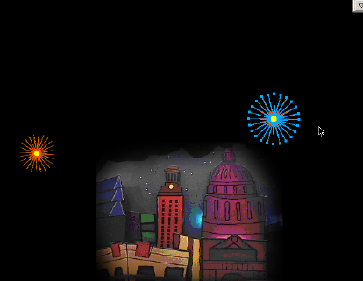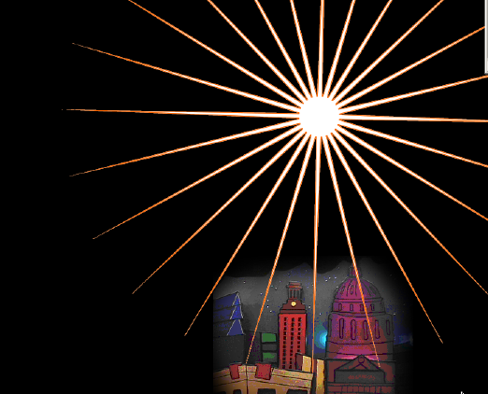 | We’re going to create stars, then, using frame by frame animation, make our stars explode over the city.  Then we’ll export the file and make an “animated gif”
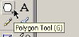We’ll create our stars with the polygon tool ,  We’ll use the distort tool to morph out our stars  We’ll use the Pointer tool to re-select our stars  Use the subselection tool to move around sections of our star | 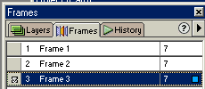  …And use the Frames window to change our stars, frame by frame
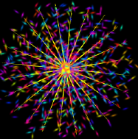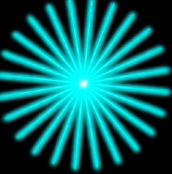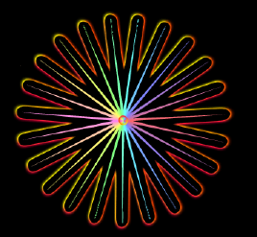 | 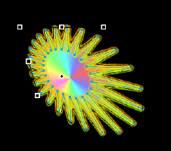
Start up Fireworks | Open the file called “austin_kiddie_limits”  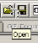
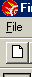  OR, if you want a plain background, Click the New File button at the top left.  make our background  10 inches wide and  8 inches high  And the background probably black for night | 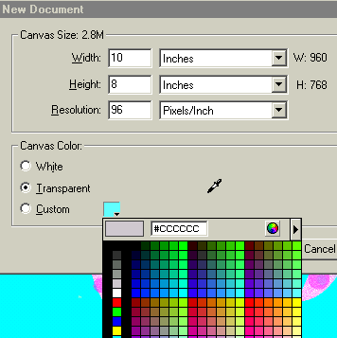Be sure and choose Inches, not Pixels
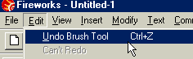 | Your Magic Assistant –  Edit – Undo  Don’t be afraid to experiment – you can always Edit-undo your last step.
The Polygon tool is hiding behind the rectangle tool. Click and hold on the rectangle tool…  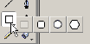And you get the choices hiding under there…  Choose the Polygon tool – it looks kinda like a stopsign | The polygon tool will draw our stars for us
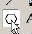  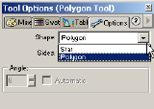 | Now, double-click on the tool, and you’ll get a new menu:  Click on the “Shape” drop down box and choose  STAR
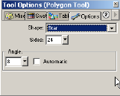 | Now, change the “sides” box to a high number, like  24  and the “Angle” to a low number, like  8
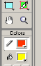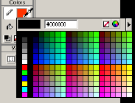  Click on the drop-down box to expand out your color choices  Choose your color  combination | Look at the toolbar on the left, towards the bottom, and you’ll see the color selectors for the:  “stroke” (the lines) – it looks like a pencil  “fill” (the insides”) – it looks like a bucket
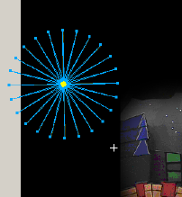 | Now, just click and drag, and you’ve drawn a star with 24 points!  Note that it looks blue.  This is because it’s still selected, and any changes (like color, for instance) you make will change your star
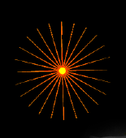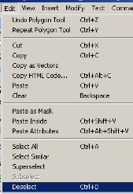 | To Deselect your star,  Hold down the Ctrl key and the letter “d”  OR  Click  Edit--Deselect  Now you see the true colors!
 | To Re-select your star, you’ll use the pointer tool
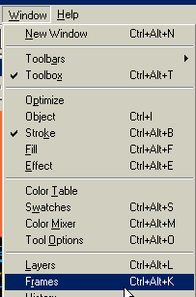  Let’s open the Frames Command Window. | Now we’re going to do the animation part – we’re going to explode that Star!
NOTE – IF YOU STARTED WITH A BLANK DOCUMENT, YOU’LL NEED TO ADD YOUR OWN FRAMES  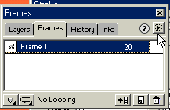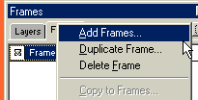 | In the Frames Command Window, click on the little box there at the top right – it’ll expand out a menu.  Choose Duplicate Frame – AND ADD AT LEAST THREE OR FOUR FRAMES
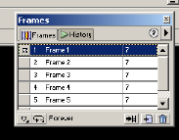 | There Are four more frames waiting for your star to explode
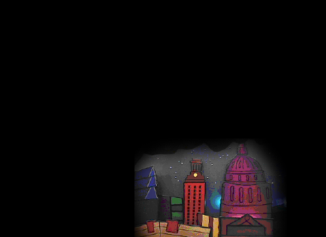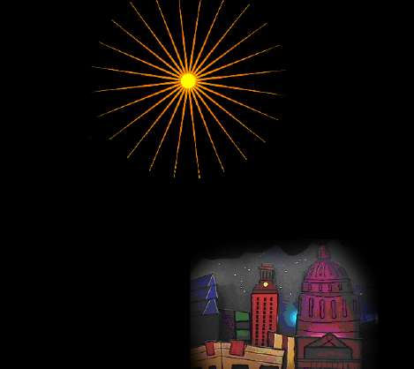 Now, draw the same star again, but in a slightly different place – and maybe a different color and maybe bigger or smaller | Click on  “Frame 2”  and you’ll see it’s blank
Great job. 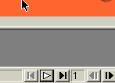 | Now look at the bottom right of your screen – see those controls that look like VCR buttons? Those will “play” your fireworks star
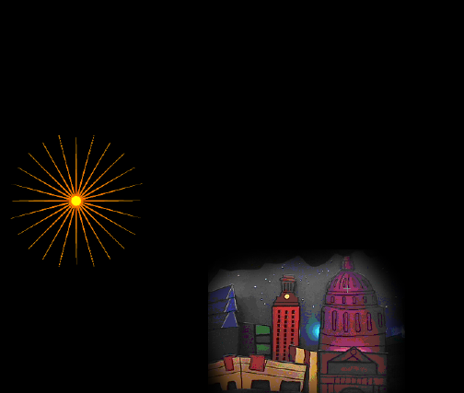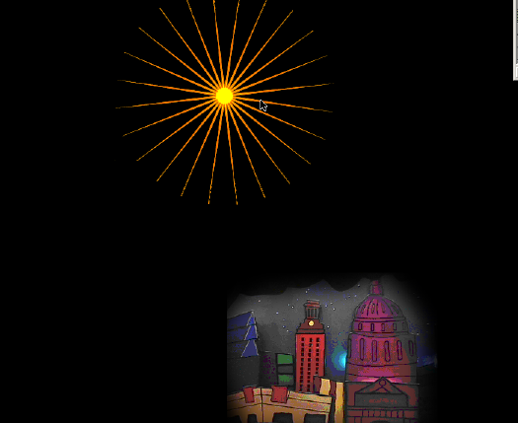 | Now, Click on Frame 3 and draw the same star again, in a different place, a different size, different color.  Then play back your results.
Change Up Your Stars  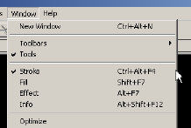 | To get a million different styles of stars, open up the  Stroke  window
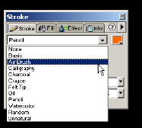 | Click on the drop-down box where it says “Pencil”, and choose another stroke  Try Airbrush
Here are the elements chosen to get this star:
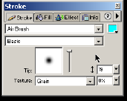
 | 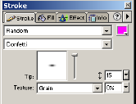
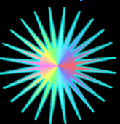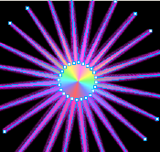  To get a bigger center, change the angle of the star to a higher number. Double-click on the Polygon tool again, if you need to, to open up this menu. This star is Angle: 32 – Sides -- 24  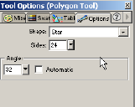  : | To get the cool pointed center, go to the  Fills  Tab and choose  “Cone”  And “Pastels”  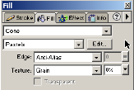
To get this exact star, change options on all three menus – Stroke, Fill, and Polygon  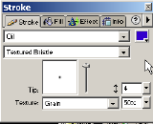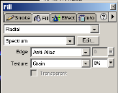  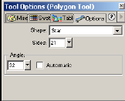 | 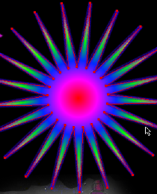
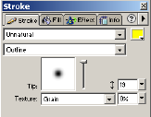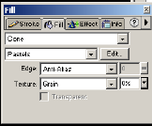
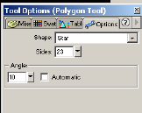
Better Explosions!  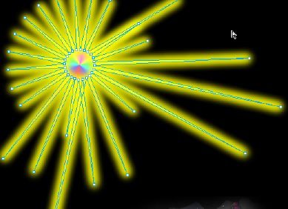  For best effect, put the same star in several frames, and stretch it out bit by bit over the several frames… | Use the subselection tool to move around sections of our star  Just Click on the “Points” at the edges and Pull out!  Note – this star is Air Brush…  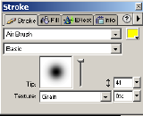
Better Explosions II | Distort & Skew
We’ll use the distort tool to morph out our stars | use the Pointer tool to re-select the star
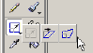Click and hold the Scale Tool to get to the Skew & Distort Tools | 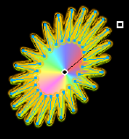
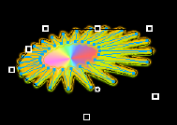 | Now Click and Drag on the “handles” until you get the effect you like.  You can combine the Transform and the Subselect morphing tools
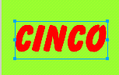 | Let’s make some text explode!  Create some text.
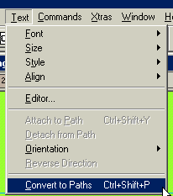 | With text selected, go to Text—Convert to Paths.  With the subselection tool, click away from the text, then click on the letter you want to change.  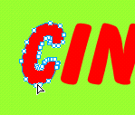  Note that now it’s a path with bunches of path points
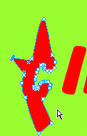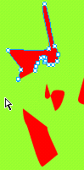 | Now with the subselection tool, you can grab at the points of the letter and make it look any way you want.  You can even “explode” the letters piece by piece.

How to save your movie!
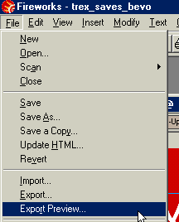 | Go to “File—  Export Preview”
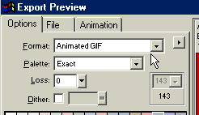 | Make sure the format is  “animated gif”
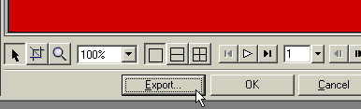 | Click “export”
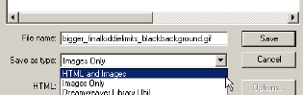 | Under “save as type”, choose  Html and images
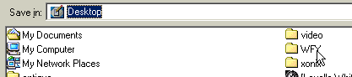 | Be sure you save to the wfy folder!!!
 | Give your movie a name and click “save”
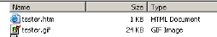 | It’s saved as an Animated gif already inserted into an HTML file.  Click on the HTML document to play your animation.
TO PUT FIREWORKS SOUND EFFECTS IN YOUR ANIMATION!  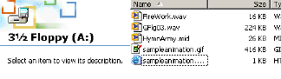 | Save (or copy) the two files onto your floppy disk
Open up Dreamweaver | 
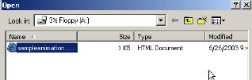 | File—open your HTML page in dreamweaver
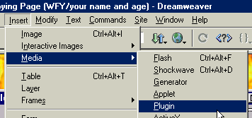 | Go to  Insert – Media – Plugin  You may want to cursor down to the end of the page if you want your Media Player to appear at the bottom rather than at the top.
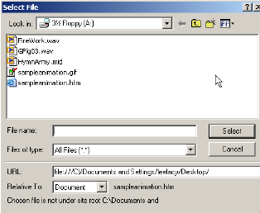 | There’ll be a couple of sound files on your disk – choose one and click Select.  When the music file is inserted, you’ll see this symbol:  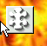
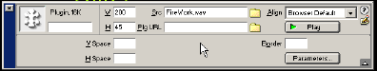 | To get a full-sized player, choose  W: 200  H: 45  To get no player, put in 0 for both Width & Height
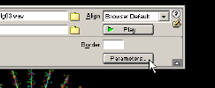 | To get your music to loop forever,  Click Paramaters
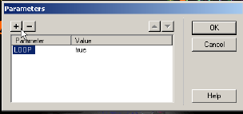 | Click the  + button  and then type in  loop for parameter  true for value
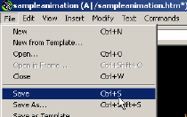 | Save your page to the disk again.  If asked if you want to replace the file, choose  yes
Click on the HTML document to play your animation.

Listen to the music!
Make an Animated greeting card and send it as an email attachment to your friends!

