We’re going to create Claymation Animations  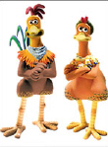 | We’re going to take multiple pictures, then, using frame by frame animation, turn our pictures into an animated gif.
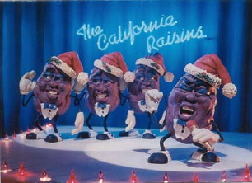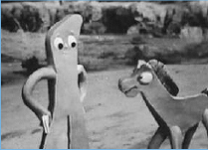 | Lots of cool movies & shows are actually Claymation – Nightmare Before Christmas, James & the Giant Peach, Chicken Run, Gumby & Pokey, The California Raisins…
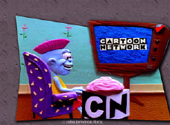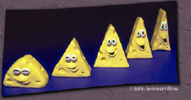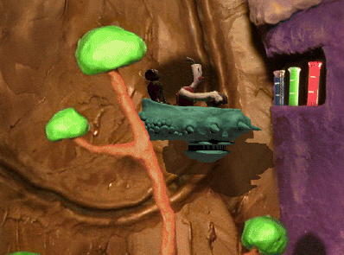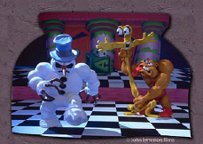 | Tips:  - Keep shapes simple  - Keep action to 10 frames or fewer  - Put one object that doesn’t move at the edge of the frame to use to keep the frames steady  - Make a lot of tiny changes between each frame to make your creations seem alive!
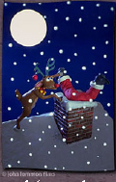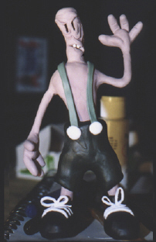 | 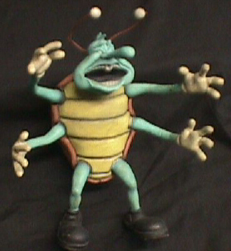Remember you can add titles to advance the story in post-production.
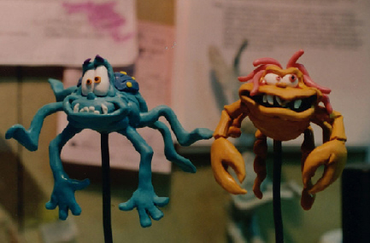 | 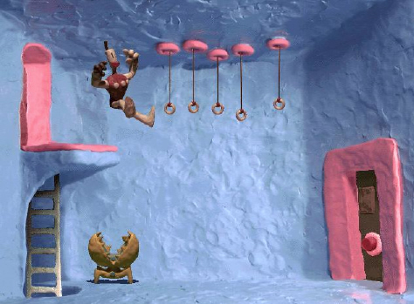
Start up Fireworks
Got your disk with your pictures on it?  Start here! | Go to:  File –  Open multiple
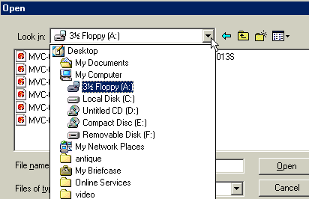 | Click on  3 ½ floppy (A:)
Important – be sure to choose the “open as anmation” option!!   | Go to the Click on the files you want to add to the animation – in this case, probably “add all”  Important – be sure to choose the “open as anmation” option!!!
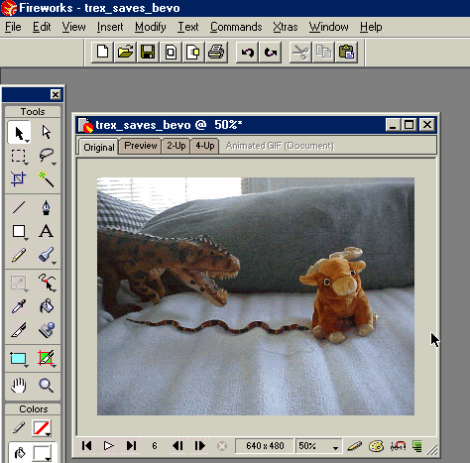 | It’ll look something liKe this…
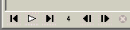 | Find the “vcr” controls and play the pictures!
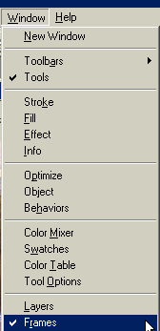  The Frames window | Want to change it up some?  If it’s not already open, open the frames window.  Go to:  Window---frames
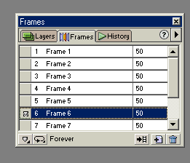  click a different frame and see how the movie switches to a different picture… | When it’s open, it’ll look about like this…  You can change the length of individual frames by clicking in the 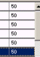right column and just typin g in a longer or shorter number.
Would you like to add opening titles or closing credits?  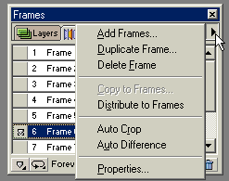 | To add more frames, click on the little triangle at the top right of the frames window…  You’ll get this menu.  To add credits, click  “add frames”
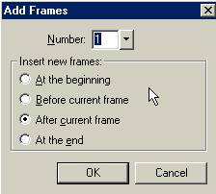 | To add opening credits, click  to add closing credits, click
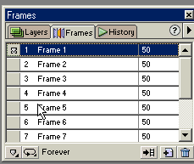 | To add openi ng credits, go to frame one in the frames window…  It should be empty
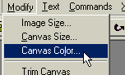 | To change the color of the background, go to:  Modify---  Canvas color
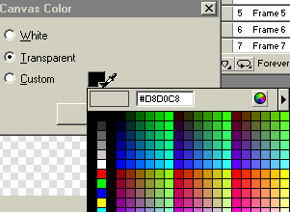 | Go to custom, click the drop-down box by the color , and choose your favorite color for the background…
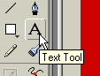 | To add words, click on the text tool at the left of the screen…
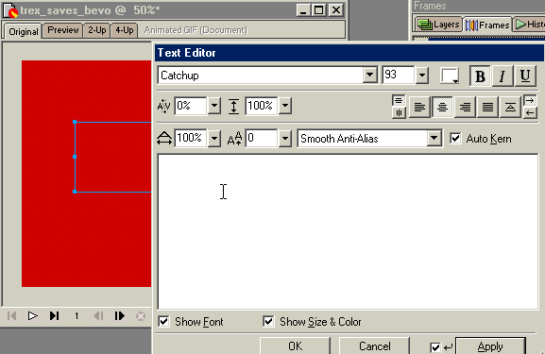 | Click and drag a text box and write in the name of your movie, or titles to advance the storyline

How to save your movie!
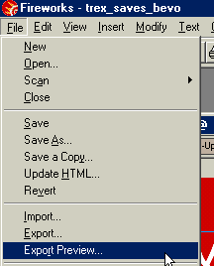 | Go to “File—  Export Preview”
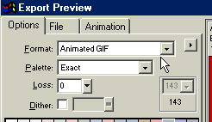 | Make sure the format is  “animated gif”
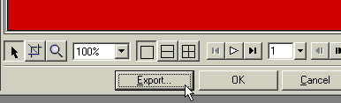 | Click “export”
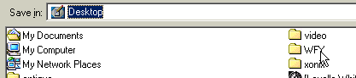 | Be sure you save to the wfy folder!!!
 | Give your movie a name and click “save”
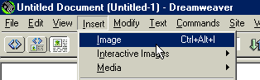 You can insert your movie into your web page in Dreamweaver – just click Insert—Image! | It’s saved as an Animated gif and will have the .gif at the end.

