Political Caricature
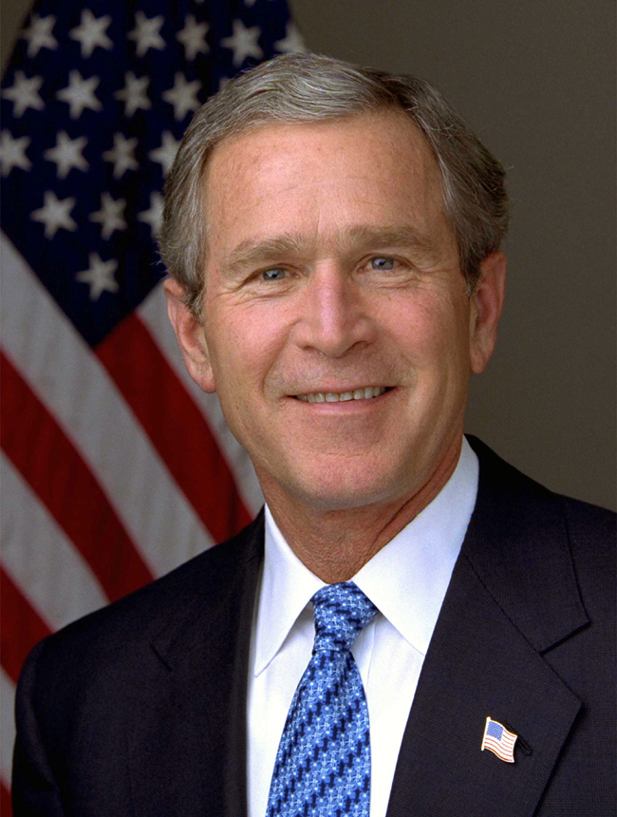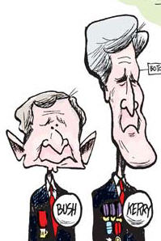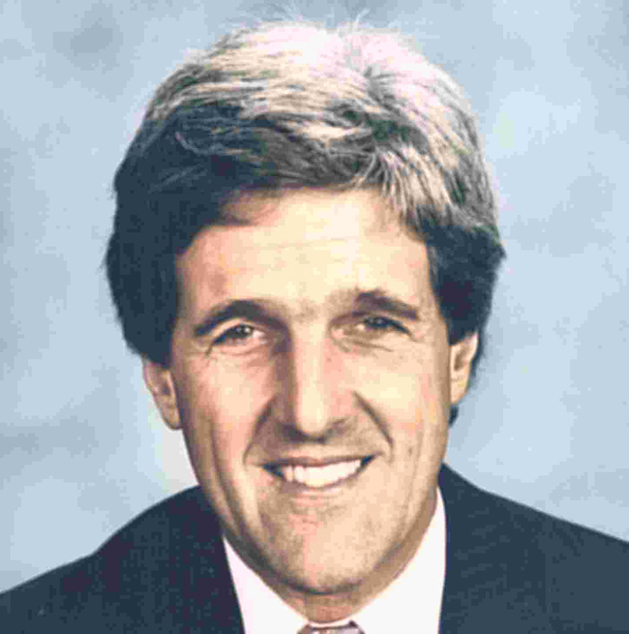 | Have you ever heard the expression “A picture is worth a thousand words”? A caricature exaggerates to tell a story or to make a political point.
Political cartoonists often exaggerate – usually George W. Bush is drawn with large ears and no chin, and Senator John Kerry is often drawn with a long chin and big hair. | We’ll use Photoshop software to create political caricatures just by changing a photo – NO DRAWING REQUIRED – then we’ll morph the caricatures frame-by-frame.
 | We’ll Open Photoshop Elements
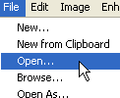 | Click File—Open and choose which picture you want to caricature.
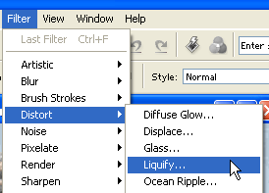 | Click on Filter—Distort—Liquify.
Warp  Turbulence  Clockwise Twirl  Counter-clockwise Twirl  Pucker  Bloat  Shift Pixels  Reflection  Reconstruct Tool | You’ll see a lot of tools at the left.  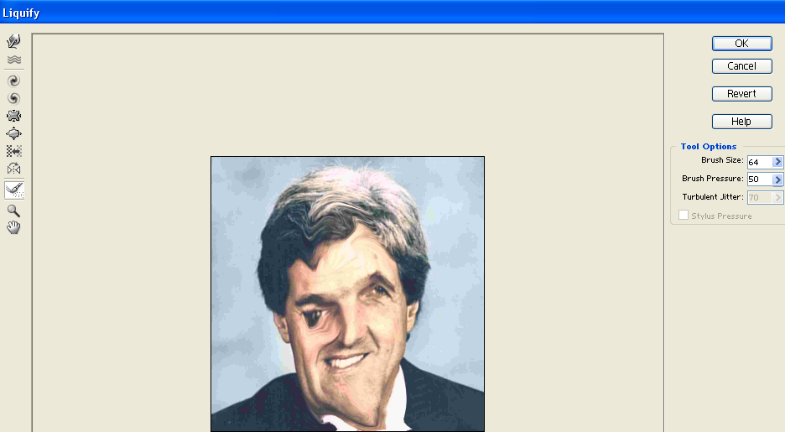  We’ll learn them all.
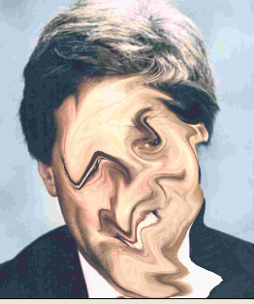 | For fun, let’s use the Warp tool and liquefy, with a result sorta like this:
Now look at the menu on the right – you can choose to Revert  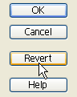 | When you click the Revert button, the picture will go back to the beginning. 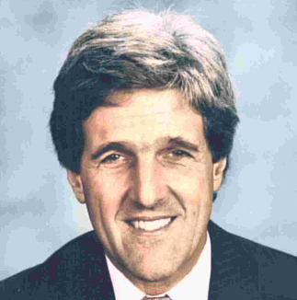
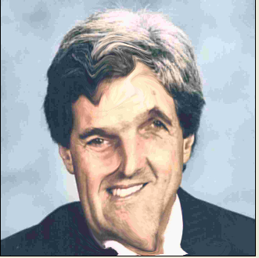 | Warp again, and this time use the Reconstruct Brush to revert just parts of the picture.
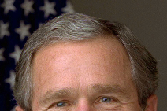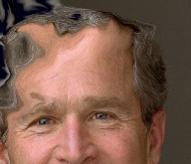 | The Turbulence Tool scrambles the pixels – use it to push back a hairline…
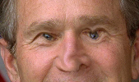 | Use the Twirl tools to make weird eyes and a crooked nose…
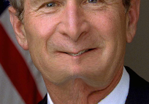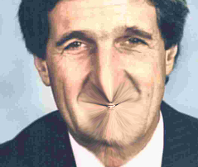 | Use the Pucker Tool to pucker up the mouth & chin…  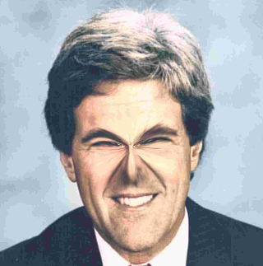 or around the eyes…
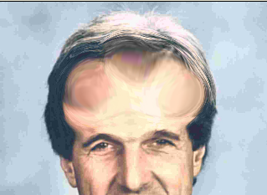 | Use the Bloat tool to make a really big brain…  …or ears  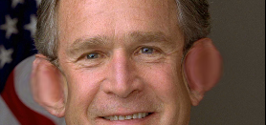
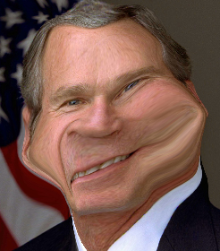 | Use the Shift Pixels tool to put some weight on…  …or just rearrange features…  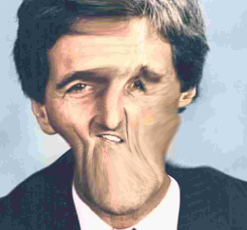
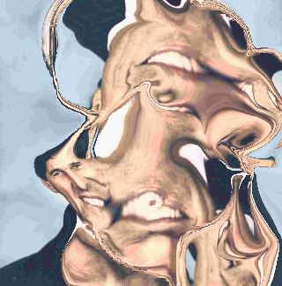 | The Reflection tool makes copies of different areas of the picture, with interesting results.  Keep stirring and see what you come up with!
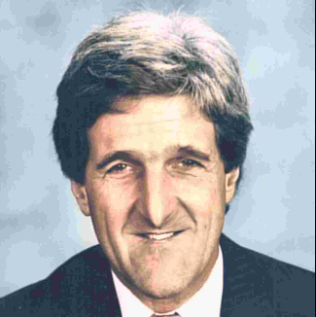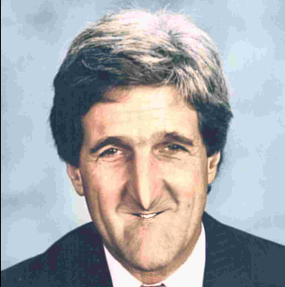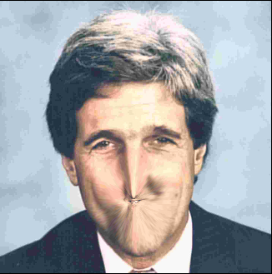 | If you like your result, click OK  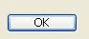
To add Cartoon Bubble Text: | 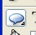Choose the Shape Tool.
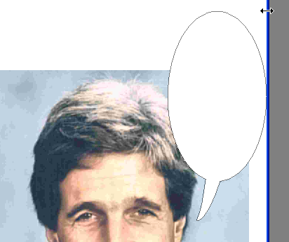 | Draw in the Cartoon Bubble Box.
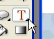 | Now, to put your words in, choose the Text Tool.
 | Look at the top – the Text toolbar will show up – you can choose text style & size & color.
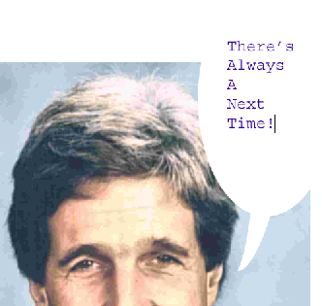 | Type in your words – make sure the color of the letters will show up on the white box.
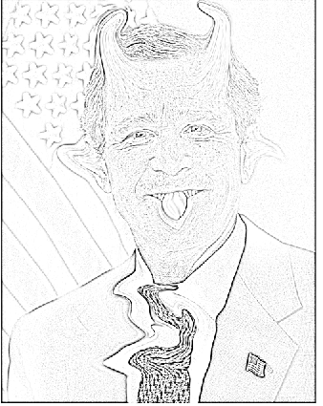 | If you’d like your picture to look like you drew it, try one of the Sketch filters – this is the Photocopy filter.  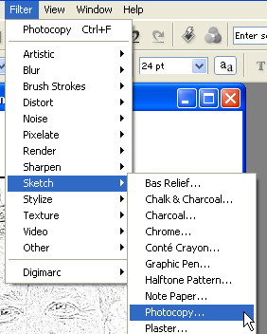
TO SAVE:
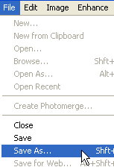 | Select File—Save AS
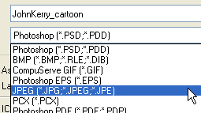 | Be sure to save as a JPEG.  Save in the WFY folder on the W: drive with your name so you’ll be able to find it.

