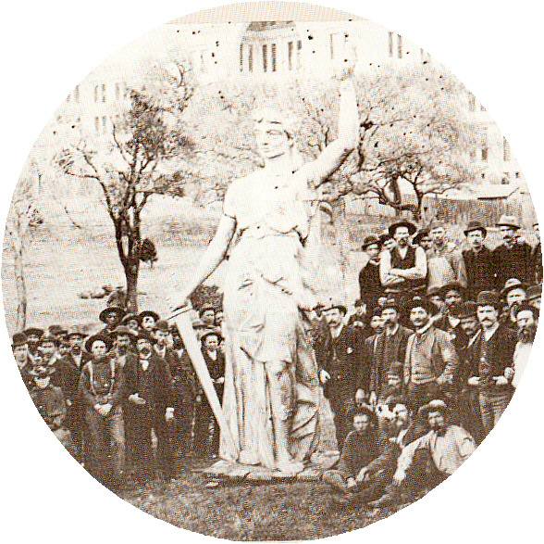 | You’ve seen old pictures, like the ones on the Austin Children’s Museum’s History Tower?  We’re going to make some new antique pictures!
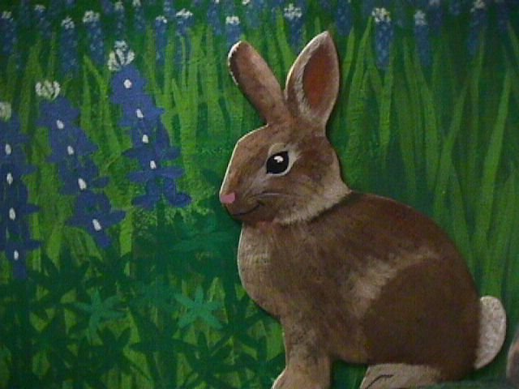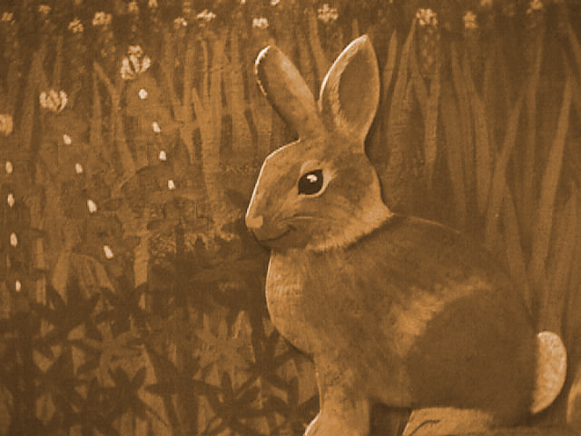 | 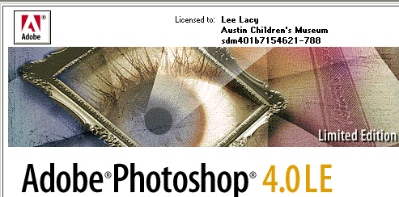  We’re going to use Photoshop
 | Open Adobe Photoshop 4.0 LE
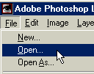 | Go to File---Open
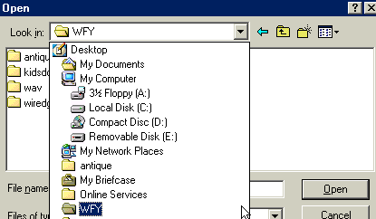 | Click the drop-down box and find the WFY folder.  Open it, then open the antique folder.
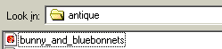 | Open the bunny_and_bluebonnets picture.  It’s from a mural at the Austin Children’s Museum.
Look here:  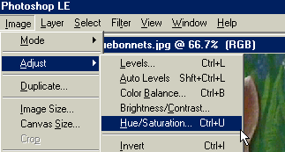 | Click Image---Adjust---Hue/Saturation
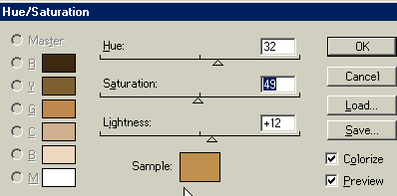 | You can type in numbers or adjust the slider bars.  To start, put in 32 for Hue, 49 for Saturation, and 12 for Lightness.  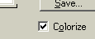  Make sure the Colorize box is checked!
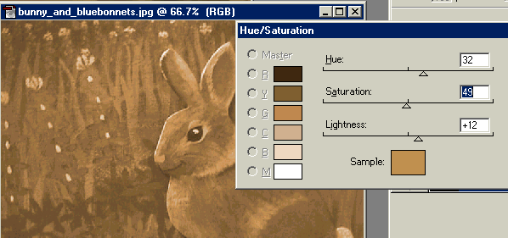 | You can adjust the slider bars until you get the picture just the way you want it.
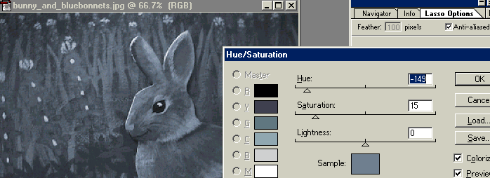 | You can also go for a blue-toned antique color – try Hue = -149; Saturation = 15.
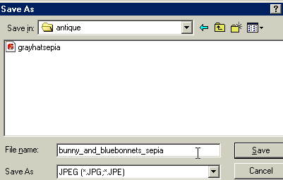 | When you get it the way you want it, go to File---Save As and save the file with a new name.
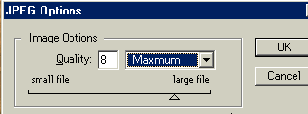 | You’ll probably want to make the Image Quality Maximum.
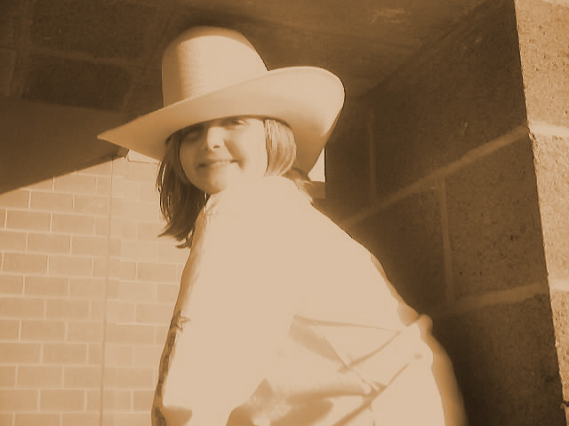Go get a costume! | Now, go get a costume from the costume wagon and get in line to have your picture taken.  You’ll be given a disk with your pictures on it.  Then come back.
Once you have your disk with pictures…..
Put your disk in the A: drive.

Click on the A drive floppy icon to open it up.

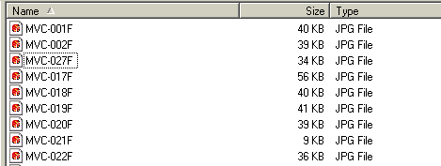 | It’ll look pretty much like this – your pictures will be numbered.
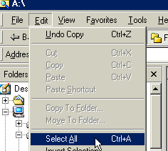 | We’re going to copy all your picture files over to the WFY folder in the computer so that you can use them.  First, choose Edit----Select All
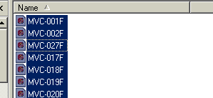 | It’ll highlight them, like this.
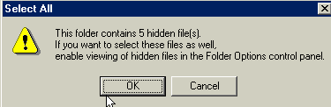 | Just click OK if you get this message.
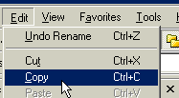 | Then choose Edit---Copy
Then, find the WFY folder and double click on it to open it.

Click Edit—Paste to put the files in the WFY folder.
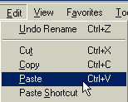
How to create your own folder:  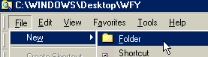 | If you like, you can add your own personal folder inside the WFY folder.  Choose File—New--Folder
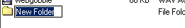 | A new folder will show up, looking just like this, with the words “new folder” highlighted. Just type in your name and press Enter.  Then double-click to open.
Then choose Edit—Paste.

Now, all your pictures are on the computer – they’ll stay there so that you can work with them in Photoshop.

How to Antique your own picture:
 | Open Adobe Photoshop 4.0 LE
Go to File---Open

Go to the folder where you put your pictures…
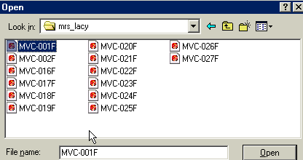 | Unfortunately, Photoshop doesn’t give you a preview – you’ll have to open each picture to see it.  Choose one and click Open.
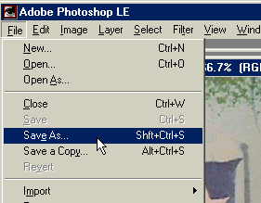 | When you find pictures you want to keep, choose File---Save As and save to your own folder inside the wFY folder.  Give it your name, plus a descriptive name that you’ll be able to recognize.  Like: Allyson_cowboyhat
Go back to page 2 where it says  Look here | Then go back t o the beginning of the lesson and antique your photo.  Be sure and use a different name when you save the photo after you’ve made changes, in case you want to do something else with the original photo.
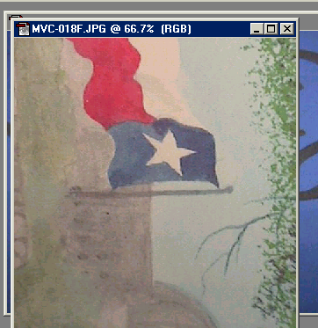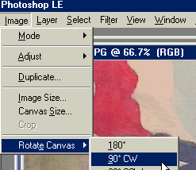 | Tip – if the picture comes out the wrong way, go to image---rotate canvas—and choose the correct degree to change it up.  Experiment till you get it right.
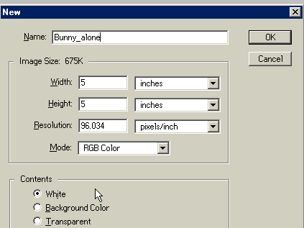 | You can create a “feathered” look by moving part of your picture to a new document.  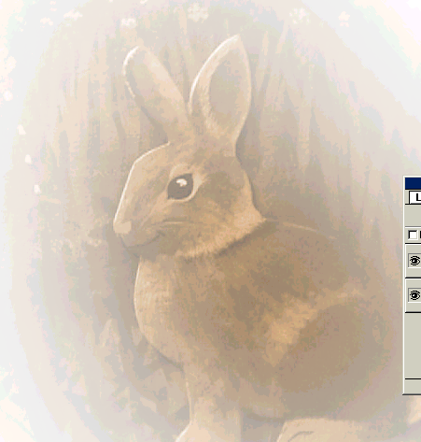  First, create a new document  Give it a name
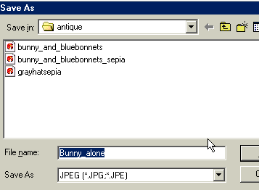 | Immediately “save as” and make sure it’s a .jpg file.
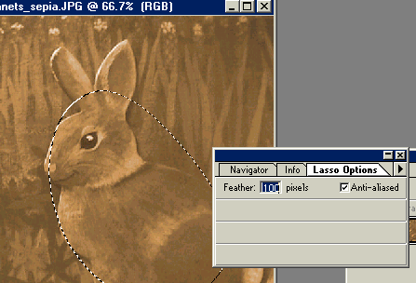 | use the Lasso tool to select part of your original image.  Draw around what you want to keep.  Make the feather box 100 pixels.  (if this box isn’t open, hit “enter” when the lasso tool is chosen)
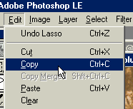 | Choose Edit—Copy.  Then go to your blank document and choose Edit—paste.
 | Very cool Effect, isn’t it?
Saving your Picture to a disk to print on the color printer: | Beginners, ask for a blank “Austin Children’s Museum” disk.
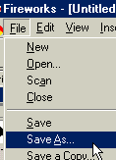 | Go to File—Save As
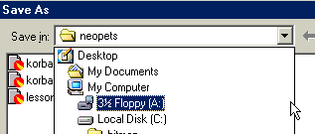 then take your disk to the person in charge of the color printer | Click on the drop-down box and click on 3 ½ floppy (A:)  Click Save  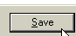
Advanced users – delete the files from your floppy disk and re-use. | Open up the floppy drive by clicking on it.  Choose edit—select all.
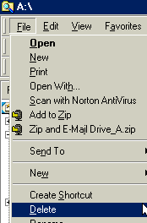 | Choose file—delete.  Then, save your new pictures to the clean floppy…

