I’m a Sports Hero!
 | This is a two-step process.  - First, we’ll remove the background from a picture;  - Next, we’ll insert that picture into a new picture and animate the new combined picture  
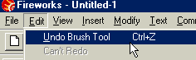 | Your Magic Assistant –  Edit – Undo  Don’t be afraid to experiment – you can always Edit-undo your last step.
Here are the important tools:  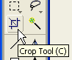 The Crop tool will select just the part you want to keep – just select and double-click | First, let’s learn how to remove the background from a picture:  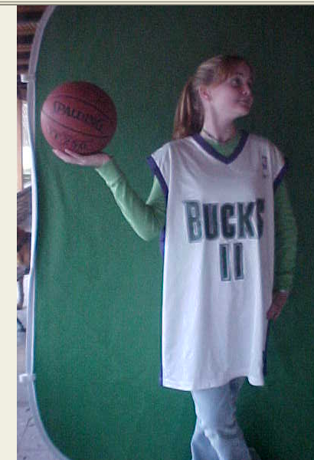
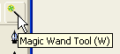The Magic Wand Tool selects areas by color  Select areas you want to remove and hit the DELETE key | 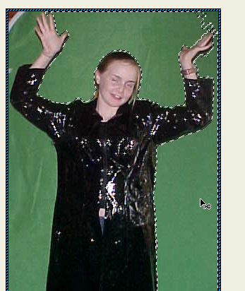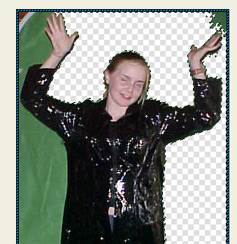
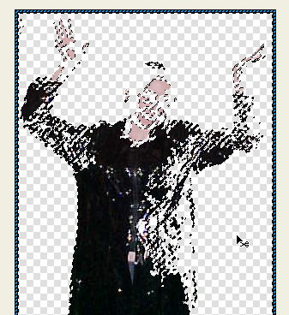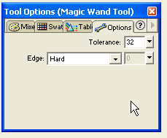 | If the Tool Options box for the magic wand tool isn’t open, you can open it by double-clicking.  If the magic wand selects too much, you can adjust the tolerance level to a lower number
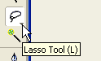At some point, it’s easier to select areas to delete with the lasso tool  Tip – after you’ve selected an area, that selection can be moved around to other areas…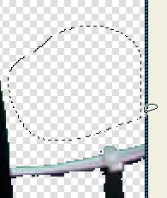 | 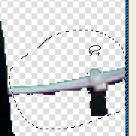Just drag and select and delete.
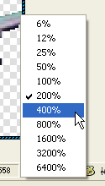 | You may also want to change the view to be able to see in closer detail what you’re doing…  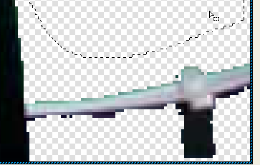
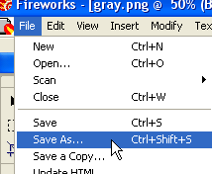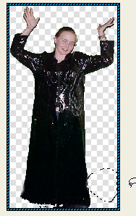 | When you’ve removed the background, save the picture to the sportshero folder inside the WFY folder on the W: drive.  Give it a name you’ll remember, cause you’ll hafta find it again
Step two –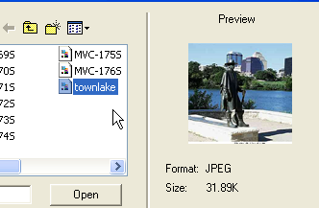 | 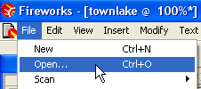  Open the picture you want as your background…
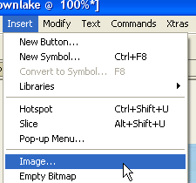 | Now bring in the picture of yourself…  Go to Insert and pull down to Image. Find the picture of yourself that you saved…  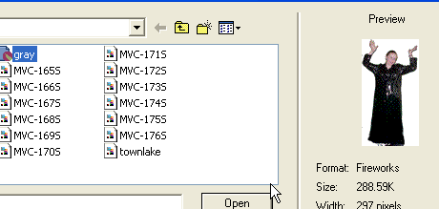
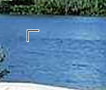 | Click Open and you get a little half square thing – click and drag this to the size you want your picture to be…
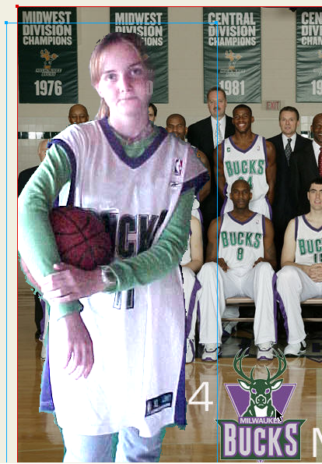 | When there’s a blue line around your picture, that means you can change it – you can move it around and re-size it
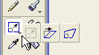  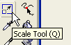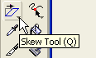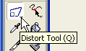 | You can also modify the picture with the Scale, Skew & Distort tool.  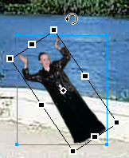
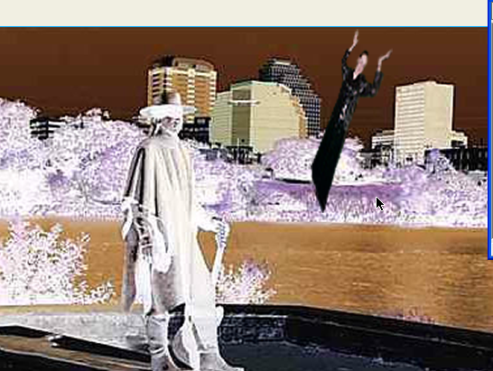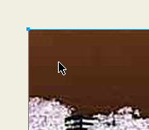 | To give a special effect to one or more frames, select the entire picture – click outside the picture, then click on the picture to select – you can tell it’s selected when there’s the same blue line highlighting the box:
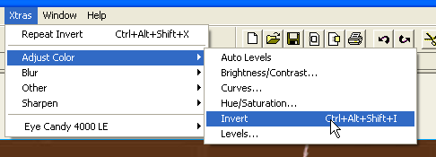 | Then go to Xtras – Adjust Color – Invert.

