We’re going to make a noisy, scary story in Microsoft Word!  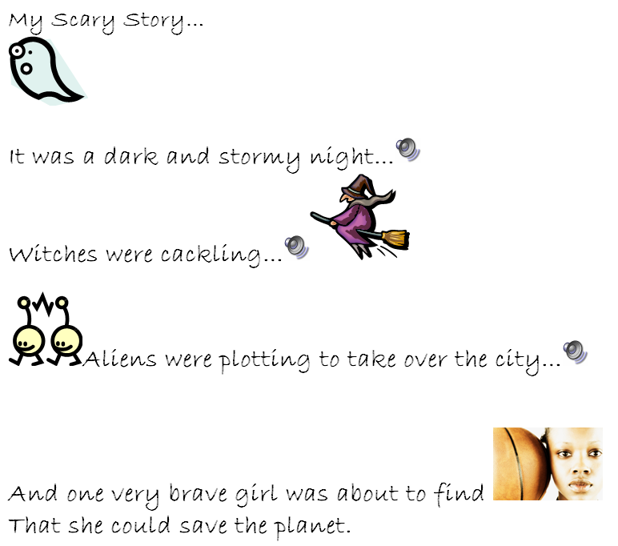 | You’ll create a story with pictures and scary sound effects that you can change up!  You’ll need speakers or headphones to hear the sounds.  
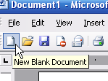 | Open Word, and create a new, blank document.
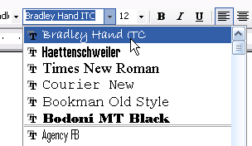 | Choose a font that will work well for a scary story…  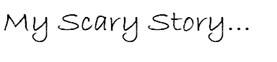  Give it a working title, as all professional writers do…
Mind blank?  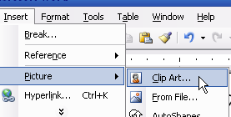 | If you can’t think what story to write, here’s a way to start your imagination: pictures!  Click on Insert..Picture..Clip Art
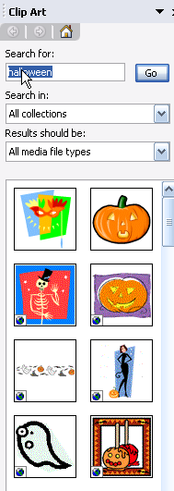 | This window should appear!  Search for Halloween, or witch, or ghost, or spider, or whatever kind of scary thing you like  Maybe just seeing the pictures will start you thinking of a story
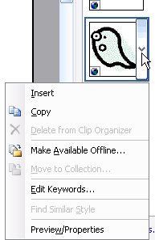 | Let’s insert a picture into your document…  Click on the one you want…  You’ll get these options – choose to Insert.  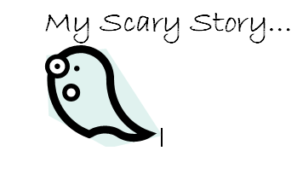
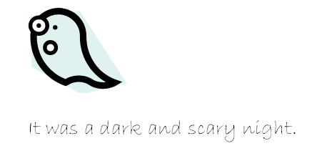 | Let’s start with a classic --
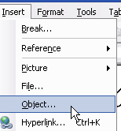 | Now let’s help out your reader by providing a sound effect to make your tale of horror more real.  Click Insert..Object
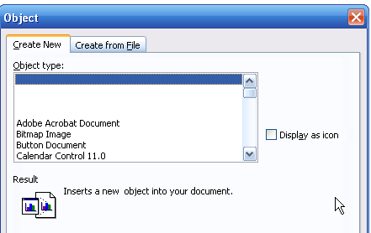 | This is what will pop up…  We’re going to scroll down until we see Wave Sound  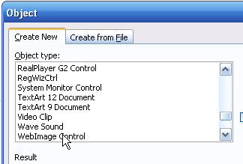
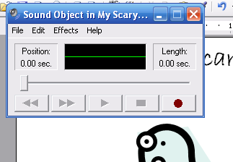 | Now this window should pop up…  It’s the Windows Sound Recorder
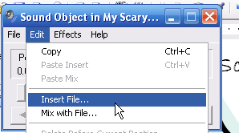 | In the Windows Sound Recorder window, click on  Edit..Insert File
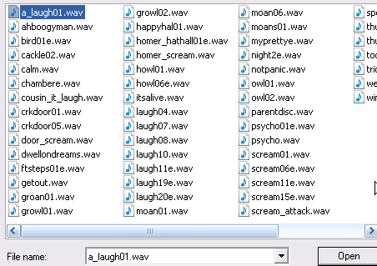 | Ask your teacher to show you where the scary sound files are on your computer – click on one to choose it and click  
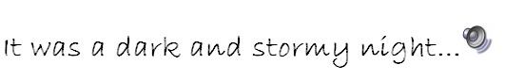 | Look! Now there’s a picture of a speaker – click on it, and see what happens…
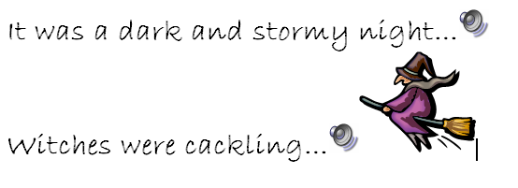 | Scary sounds, right in your story!  Repeat this process, until your scary story is done. Listen to the sound effects, browse the clip art – you’ll find plenty to get your imagination going!
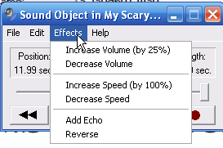 | You can also change up the sound effects…  Click on Effects – you can increase or decrease the speed of the sound, add an echo, or reverse.  Note – almost any sound file, reversed, will sound like an alien. Almost any sound file, speeded up, will sound like a chipmunk.
The mistake everyone makes –

Every time you open and listen to a new file, it adds it to the Sound Object. Check the length – you might want all the sounds, but you might just want one or two.
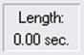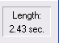
You might wind up deleting this sound object and starting with a new one, with just the sound effects you want for your story.

