Halloween Horrible
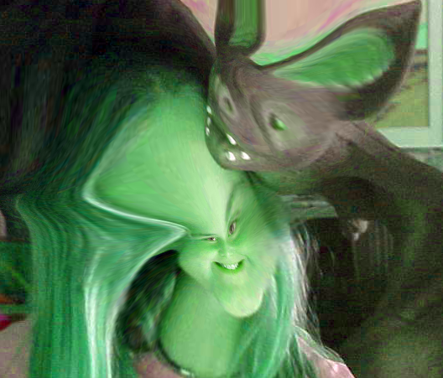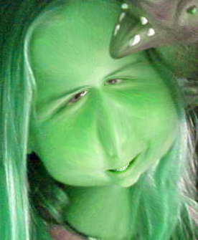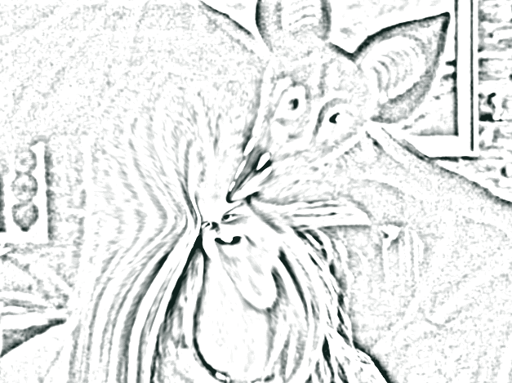 | How scary can you get? Let’s use Photoshop to find out…  We’ll also learn how to turn your finished project into a coloring page – print it out and do some creepy coloring!
 | We’ll Open Photoshop Elements  We’re using Photoshop Elements 2.0
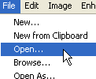 | Click File—Open and choose which picture you want to change up.
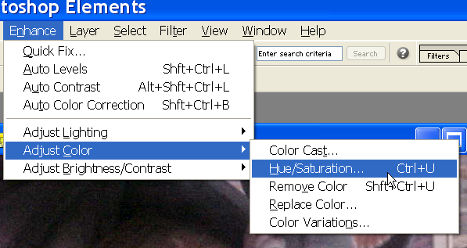 | Let’s turn somebody into a scary green monster…  We’ll turn her green…  Enhance…Adjust Color…Hue/Saturation
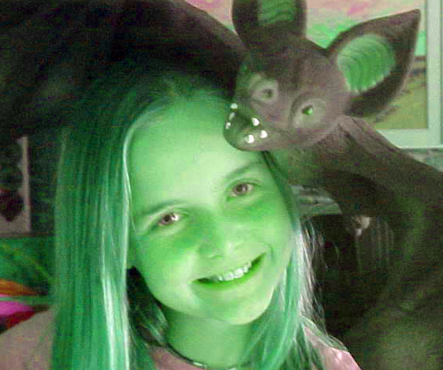 | These changes will get you that result…  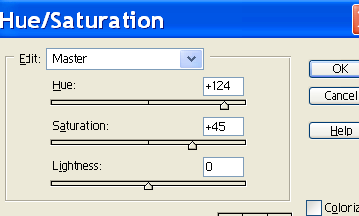  Hue – 124; Saturation – 45  Adjust the settings to get the result you want…
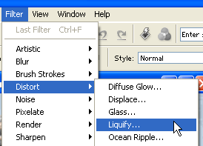 | Now let’s make some really bizarre changes…  Click on Filter—Distort—Liquify.
Warp  Turbulence  Clockwise Twirl  Counter-clockwise Twirl  Pucker  Bloat  Shift Pixels  Reflection  Reconstruct Tool | You’ll see a lot of tools at the left.  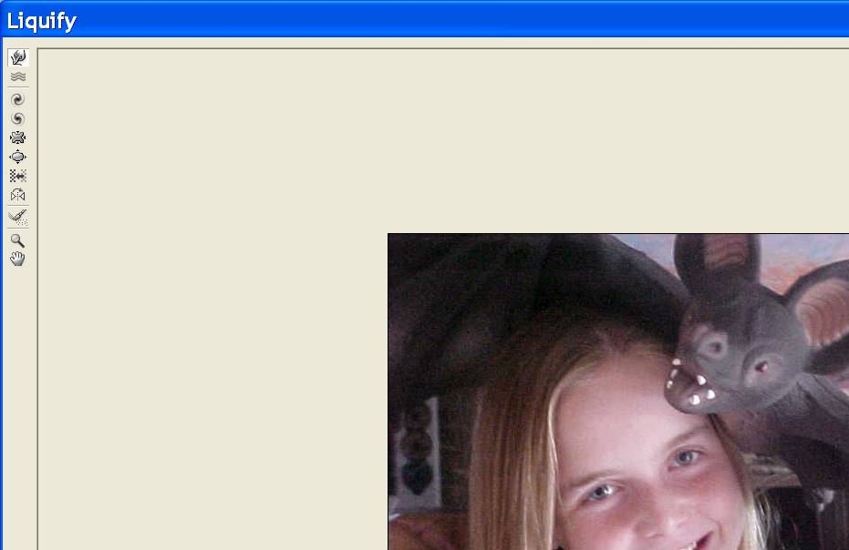  We’ll learn them all.
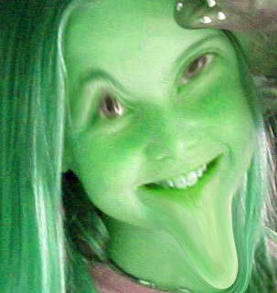 | For fun, let’s use the Warp tool and liquefy, with a result sorta like this:
Now look at the menu on the right – you can choose to Revert  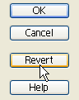 | When you click the Revert button, the picture will go back to the beginning.
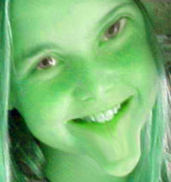 | Warp again, and this time use the Reconstruct Brush to revert just parts of the picture.
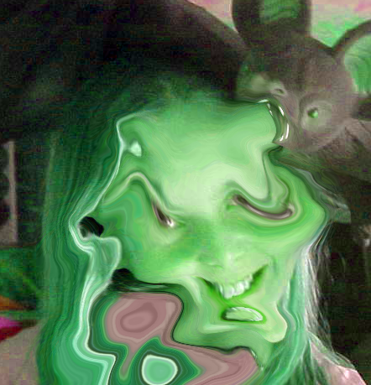 | The Turbulence Tool scrambles the pixels …
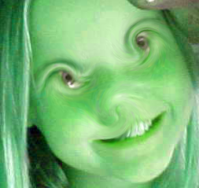 | Use the Twirl tools to make weird eyes and a crooked nose…
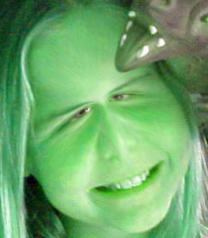 | Use the Pucker Tool to pucker up the mouth & chin…  or around the eyes…
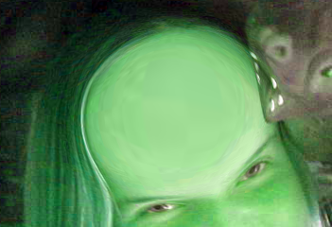 | Use the Bloat tool to make a really big brain…  …or teeth  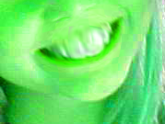
 | Use the Shift Pixels tool to get some really strange effects…
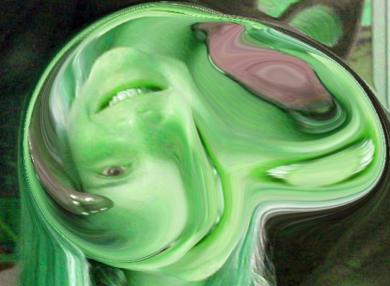 | The Reflection tool makes copies of different areas of the picture, with interesting results.  Keep stirring and see what you come up with! It’s fun to use the the Reconstruct Brush to revert just parts of the picture
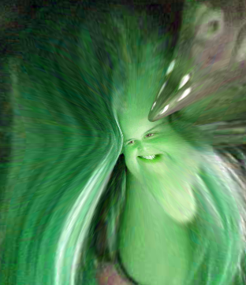 | Make a pin-head! My favorite – first, change the size of the brush: 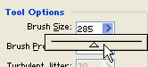 Make it big enough to cover the whole head. Then use the Pucker Tool to shrink…
If you like your result, click OK
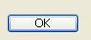
If you’d like to make your creation into a coloring page, where you can get some really terrific artistic results, try one of the Sketch filters – this is the Photocopy filter.
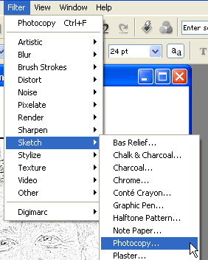
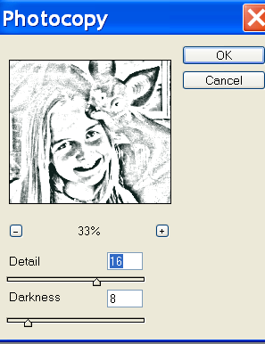 | Play with the Detail and Darkness adjustments until you get the effect you want…
TO SAVE:
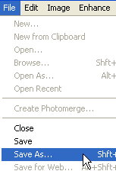 | Select File—Save AS
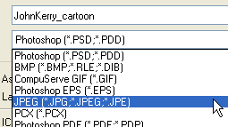 | Be sure to save as a JPEG for best quality.  And remember – you can’t believe what you see – pictures change easily be changed digitally…

