Super Tux Level Editor!

 | First, play the game awhile to get the feel of it.  Download Aunt Lee’s Help files if you need to…
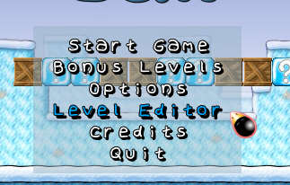 | Then open the Level Editor and build your own level for the game.  You decide where the monsters are, where the blocks are, where the bonuses are!
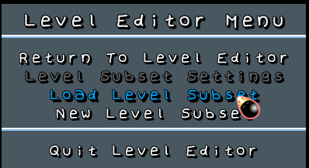 | We’ll Load Level Subset
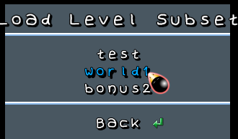 | We’ll Load world1
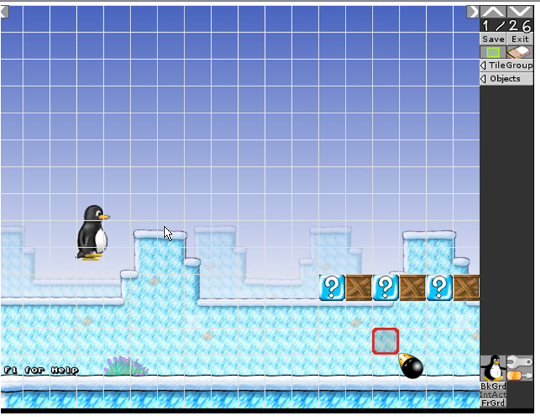 | This is what the Level Editor looks like…
 | We’ll be working mostly in the Interactive Layer. 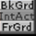  Make sure that’s selected so that your tiles and monsters will work.  Later we’ll learn about the Background and Foreground layers.
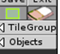  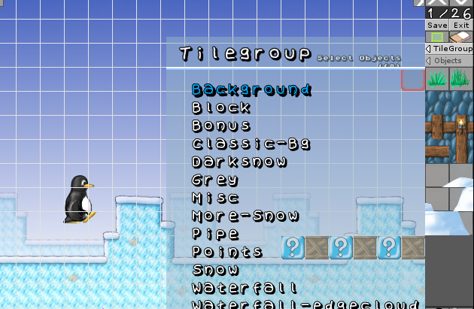 | At the top right, click on Tile Group to expand that menu…
 | And click on Objects to expand that menu…to choose Bad Guys – you put these in your level with a single click…
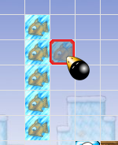 | Now select a tileset and choose a tile…  Just select a tile and “paint” it on…
 | Be sure to try out the Bonus tileset, where you can put hidden treasures in for Tux to find…
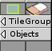 | To Change your mind, choose the eraser, then click on the tile to erase…
How to change background image and music…   | Select this at the bottom right to change the background, music, title…
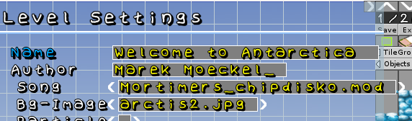 | - You can name your level by backspacing out what’s there and re-typing it…  - Backspace out the Author and put your name in…  - Select the song line and use the cursor keys to see what else is available…  - Select the Bg-Image line and use the cursor keys to see what else you can use…
How to test your level…  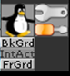 | To run your new level, click the Tux guy in the bottom right of the screen…
  Create a fun, long level – amaze your friends! | At the very top of the screen, there are scroll arrows – scroll to the right to build more of your game…

