Fantastic Voyage – Inside a Game Program
Design Levels – Platform Game.
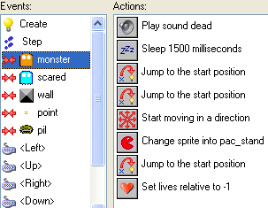 | A game tells a story – we’re going to look at how programmers use Game Maker software’s:  Sprites  Objects  Events  Actions  To tell a story in a game.
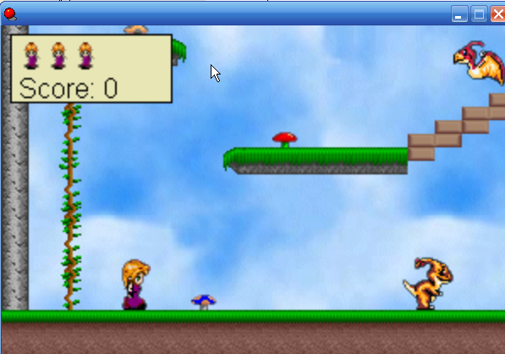 | We’re going to design our own levels in a platform game and learn the secrets of game programming…
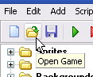 | First, open the original game and play it to get a feel for the original level…
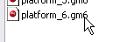 | It’s called platform_6 and it’s on the CD in a folder called platform.
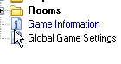 | You can look at the instructions for the game at the Game Information icon – later, you may want to personalize this info.  …And play the game 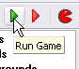
Notice that you get points for collecting mushrooms, that you lose a life when you collide with a monster, and that when lives are gone, the high score chart displays and the game restarts. | Notice how the monsters move back and forth, as if something is blocking their way – we’ll learn about this later…
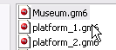 | Now, let’s open the Museum.gm6 example and get started…
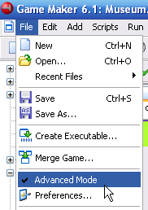 | MAKE SURE THAT ADVANCED MODE IS CHECKED!!!!!  Click File – there’ll be a check mark next to Advanced Mode if it’s enabled!
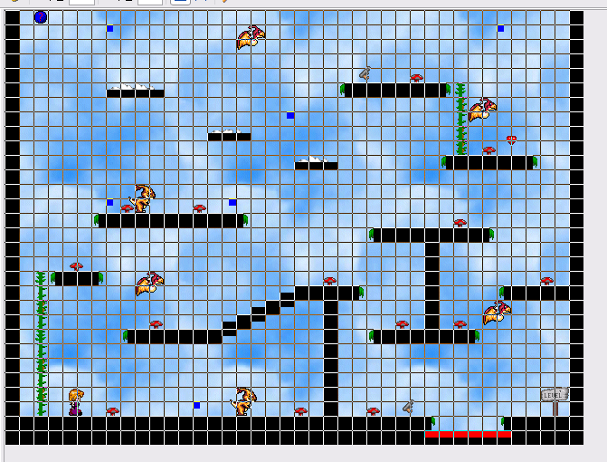 | Open the Rooms folder and go to 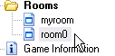room0 first, and look around – it’s easy to switch back and forth.  Be sure to MAXIMIZE the room so you can see everything  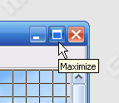
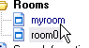 | Now go to myroom – the first one in the list.
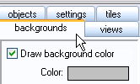 | Go to the backgrounds tab…
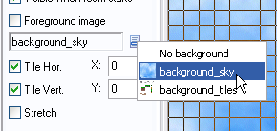 | Choose the background_sky image for now…
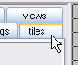 | Now, click on tiles tab…
LEARNING ABOUT TILES…  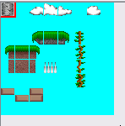 | Tiles are a standard technique used by game programmers.  They are parts of the background images – they are small and load fast.  They are not objects – they don’t have any programming attached to them.
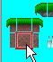 | When you click on a piece, it shows what you’re getting with a red border…
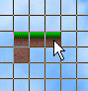 | And you click to put the tiles in the room the same way you’re used to clicking to put objects in the room… and you still right-click to delete…
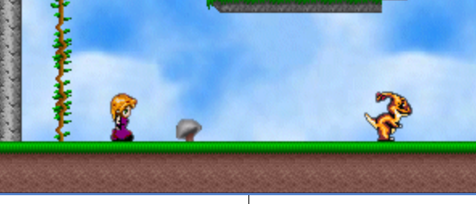 | We’ll need to have a surface for our character to walk on, so start there…
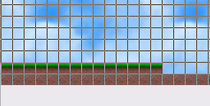 | It’s a good idea to make the surface at last two boxes deep, because we’ll probably want to add a pit of death later…
 | When you’ve got a surface started, we can put our main character in and start testing…
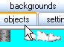 | Go to the objects tab…
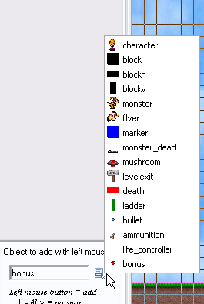 | Click on the loading icon – we’ll select the character, but first take a look at all the objects that will be available for us to use…  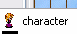
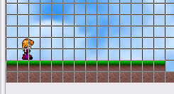 | Place the character on the ground, and run the game to test it…
 | Oops! All you get is the “ow!” as the character falls and dies!
 | Why? Because all we put in were the pretty tiles, not the block objects that are solid and that collide with the character.
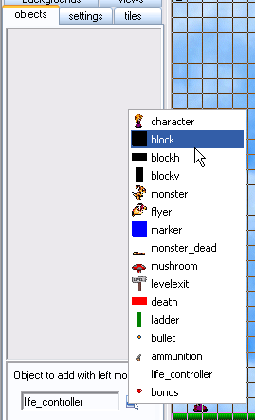 | So go back now and put in solid block objects…  When you’re on the objects tab,  Click the load icon and select a block.  Note there are several sizes to use – helpful for smaller platforms…
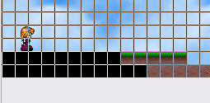 | See how the blocks cover up the pretty tiles, but test the game, and you’ll see that all the player sees are the pretty tiles…
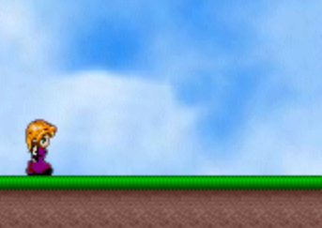 | Now it works!  Now we’ll remember to always put in a solid block object for our character to walk on…..
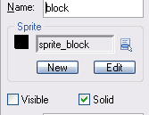 | If you’re curious, look at the block object –note that the visible box isn’t checked – so the block is invisible to the player, but the solid box is checked.
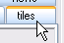 | So let’s go back to the tiles tab and keep creating our level…
IMPORTANT NOTE | You must be on the objects tab to add or delete an object, and you must be on the tiles tab to add or delete a tile!
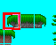 | You can use these tiles…
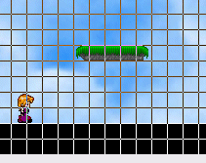 | To create a platform for the character to jump onto…
 | Just be sure to go back to the objects tab…
 | …and select a solid block object…
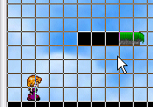 | And put a solid block object wherever you’ve got a tile platform…
 | Test your level often!!!
PIT OF DEATH!!! | Let’s Add a pit for the character to fall into…  Remember, we’ll need both the tile and the death object
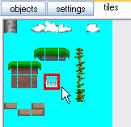 | On the tile tab, select the toothy tile…
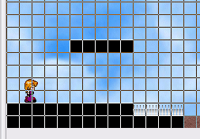 | We can make the game very hard by putting the pit of death directly under a platform (so if she falls off, she falls directly into the pit)
 | Now go back to the objects tab…
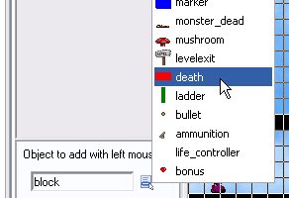 | Select death…
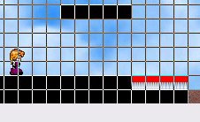 | Click to put the death object into the pit – and test…
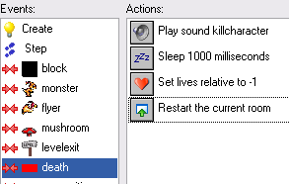 | If you’re interested, you can look at the programming for the collision event with the character and the death object.
 | Note that you lose a life when you fall into the pit of death… Let’s show the lives on the game itself…
LIFE CONTROLLER
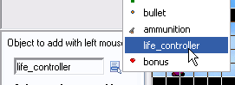 | Go to to the objects tab and select life_controller
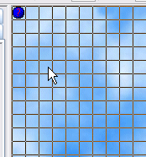 | Click to add it to the top left of the room – test it by falling into the pit of death a couple of times…
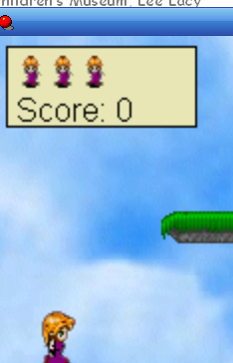 | Note that this also shows the score – let’s add some mushrooms so that the character can get some points…
ADD MUSHROOMS FOR POINTS!
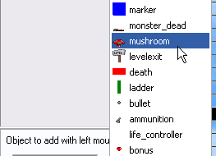 | On the objects tab, select the mushroom and put some in.
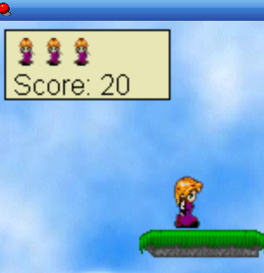 | Now test, and you’ll see some scores add up.
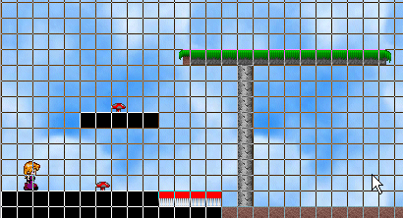 | 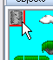Keep building – use this pole tile to create a tall pole with a platform on top
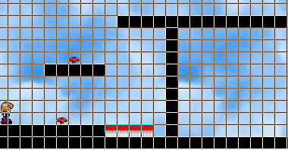 | Just be sure to switch back to the objects tab and put in the solid blocks
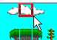 | Build floating cloud platforms…
 | Build a ladder…
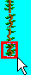 | Use the ladder tile…..
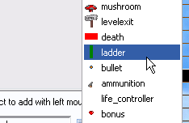 | Then put a ladder object over the tile…  …And test!
CREATE A NEW ROOM FOR MONSTERS! | Every room should get harder – let’s make a new room with monsters – but how do we get there?
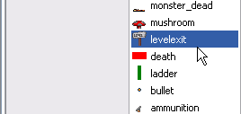 | On the objects tab, select the levelexit object!
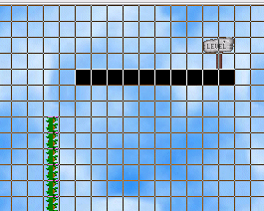 | Place it toward the end of your room…  And test!
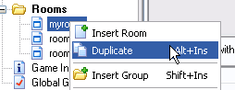 | Let’s add another room – right-click and choose duplicate…
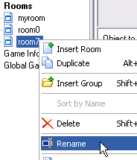 | You may want to right-click and rename it…  Then click and drag it so that it’s the second in the list, if needed…
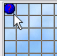 | In the new room, delete the life_controller object, or you’ll get error messages.  Put in a new life_controller in the new room – this seems to work.
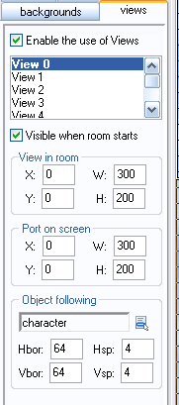 | Or, you can create a new room with the 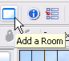 icon, to get a completely blank room – but to get the same effects, you’ll need to set up the view menu like so…
LET’S ADD MONSTERS! | Remember how the monsters moved back and forth, back and forth?
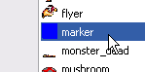 | It’s because the game programmer put in marker objects (that are invisible to the game player) that the monster bounces off of…
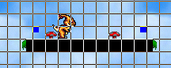 | So when you put in a monster, also put in two markers to keep the monster moving back and forth…
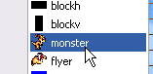 | Select the monster…
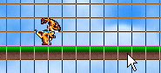 | Put him on the platform…
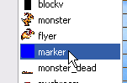 | Select marker…  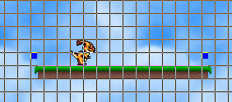  Put him on the platform… test!  Remember that the character can squash the monster if she jumps on him.
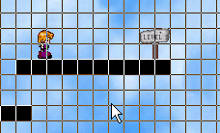 | NOTE: To make it easier to test the second room, you can put the character close to the end of the first room, then put her back later…
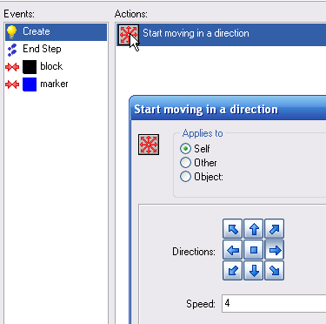 | If you want to make the monster move faster or slower, you can go to the monster object, to the creation event, the start moving in a direction action, and change the speed.
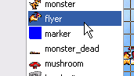 | You can add a flying monster the same way – but the flying monster doesn’t need to be on a solid surface – he can fly…
AMMUNITION… | You can arm your character against the monsters with ammunition…
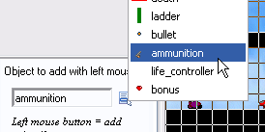 | In objects tab, select ammunition, and place it somewhere in the room where the character can get it…
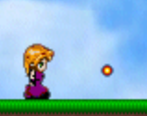 | Now she can shoot monsters with the spacebar…
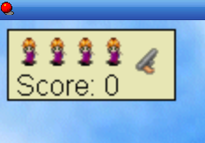 | And the ammo will show up on the scoreboard…
CREATE A NEW MONSTER SHORTCUT | Let’s make a new monster who moves up and down…
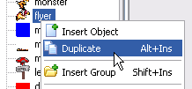 | Right-click the flyer monster and choose Duplicate
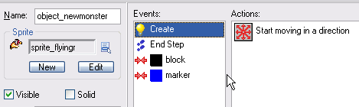 | Go to the creation event and click the Start moving in a direction icon.
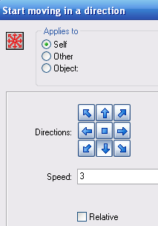 | Un-check the right arrow direction  Click the down arrow direction  Change speed if you like…
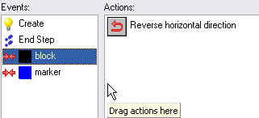 | On both the collision-block and collision-marker events,  - Delete the reverse horizontal direction  - Drag reverse vertical direction…
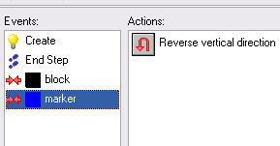 | So it looks like this…
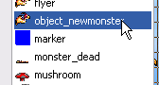 | Now, when you select the new object in a room…
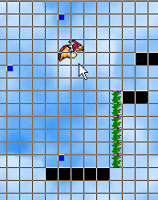 | Place him somewhere where he might collide with the character, with markers above and below, because he’ll be moving up and down…
CHANGE SOUNDS?
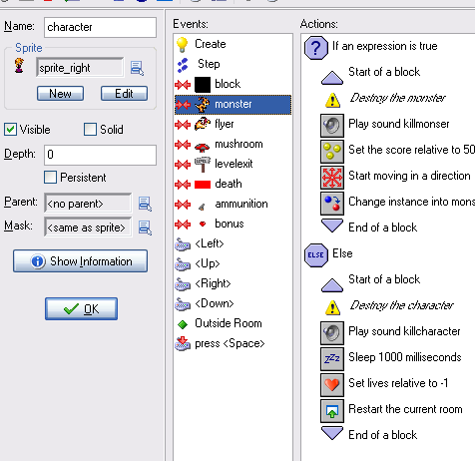 | To change the sound in a collision, go to the character object, select the collision event you’re interested in, find the play sound actions, and change them.  Go to Add a Sound first, if you want a new sound…  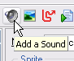
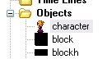 | Okay – I know you guys – whatever I say, what you’ll want to do first is change the main character – but there’s a problem.  Open the character object…
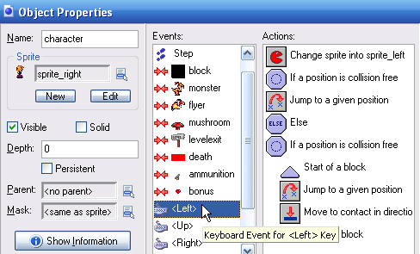 | Click on the Keyboard event for the LEFT key, and you’ll see that when the left key is pressed, there’s a Change sprite action – if you want to change the character sprite, be sure to change it here as well – preferably with a left-facing sprite.
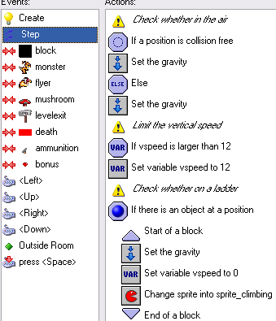 | AND, when the character climbs, the sprite changes to a climbing sprite,  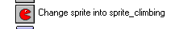  So you would need three sprites.
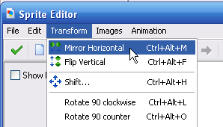 | Then add the same sprite again, go to 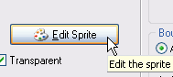  And click Mirror Horizontal…
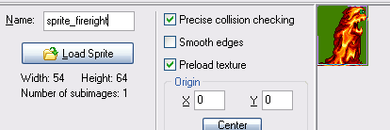 | And save with new name…

