Fantastic Voyage – Inside a Game Program
Catch The Monster – Our First Game
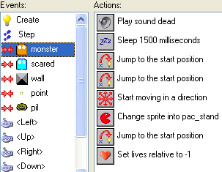 | A game tells a story – we’re going to look at how programmers use Game Maker software’s:  Sprites  Objects  Events  Actions  To tell a story in a game.
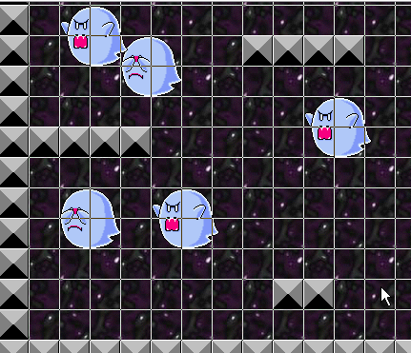 | We’re going to create a Catch the Monster game from scratch.
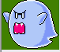 | We’ll need a monster sprite and a wall sprite
Click the Add Sprite icon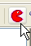 | Let’s add a new picture, or “sprite” to be the monster that we catch.
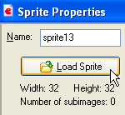 | Click the Load Sprite button. Look in the different folders – choose a good one.  I’m going to use a Mario monster
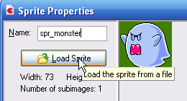 | It’s a good idea to name your sprites so you can find them later. Never use a space in the name!
 | Now we’ll add the Wall Sprite
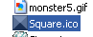 | Choose the square and name it.
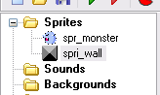 | To the left, the sprites folder should look like this…
 | Now we’ll add two sounds – one when the monster hits the wall and one when he’s clicked on.
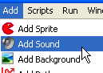 | Let’s add a couple of sound files to use in our game.
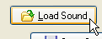 | Click load sound – search around and test the sounds.
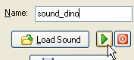 | Load the sound and test it – give it a name you will recognize.  Do this for both sounds
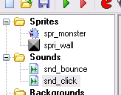 | Now our folders swill look something like this…
 | Now we’ll add an object
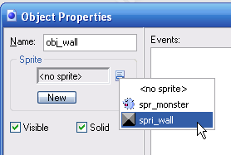 | We’ll start with the wall.  Name it obj_wall  Select the wall sprite
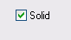 | VERY IMPORTANT!!!  Make sure the Solid box is checked – or the wall won’t work.
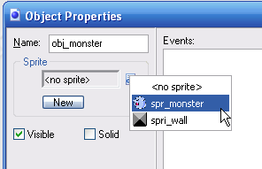 | Great! Now let’s add the monster object…  Name is obj_monster and choose your monster sprite.
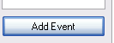 | Now to start the really exciting stuff. We’re going to add events (and then actions) to the monster.
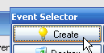 | Choose the Create Event
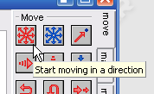 | Now click on the red Start moving in a direction icon on the right and drag it over.
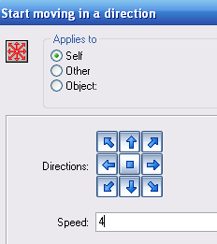 | We’re going to click on all the arrows except the middle one, to start the monster in motion.  And we’ll click 4 for the speed.
 | Now we’re going to define what happens when the monster hits the wall – a Collision Event
Add Event button again, and choose Collision
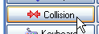
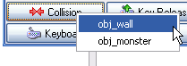 | Select the wall object
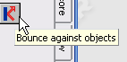 | Now click on the Bounce Against Objects icon and drag it over.
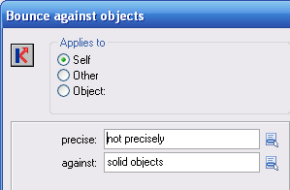 | We’re not going to make changes – the defaults are fine.
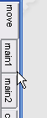 | We want to assign a sound to the collision – to get to the sound icon, click the Main1 tab along the side there.
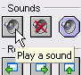 | We’re going to click and drag the first one in the row - Play a sound.
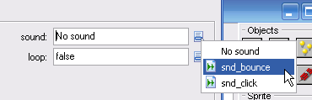 | Select the sound you called snd_bounce. Aren’t you glad you labeled it?
 | Now we’ll define what happens when the game player clicks on the monster.
Click Add Event again and choose Mouse
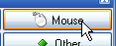
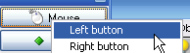 | And click Left button
This Game will keep a Score! 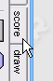 | To get to the auto score functions, click the score tab to the right…
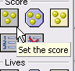 | The first one is the Set the score icon – click and drag it…
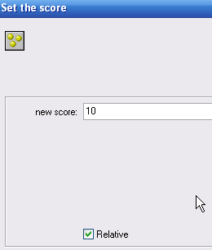 | Set the new score to be 10 – or 100,or 1000 – you’re the programmer.  Click the Relative box so that each click increases the score.
 | Remember how we added the sound?
 | We want to assign a sound to when the monster is clicked on – to get to the sound icon, click the Main1 tab along the side there.
 | We’re going to click and drag the first one in the row - Play a sound.
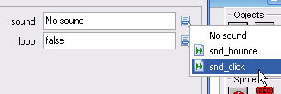 | This time we’ll choose the click sound.
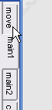 | We want the monster to move in a new random direction after he’s clicked on.  Click on the move tab to get to the move icons
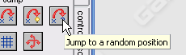 | Select the Jump to a random position. Just click okay – the defaults are fine.
 | We want our monster to keep moving and even to speed up --
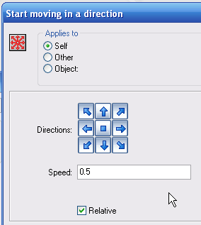 | Choose the Start moving in a direction again – again, click all the arrows –  For speed – write in 0.5  Be sure to click the Relative box, so the monster will move faster every time he’s clicked on.
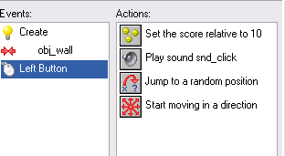 | Look at all the programming you’ve done!
 | Now we’ll put the room together
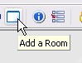 | Click Add a Room
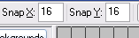  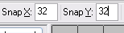 | First, we’ll change the grid so our guys will fit more easily – change from 16 to 32
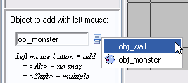 | Maximize the window.  Let’s add the wall first
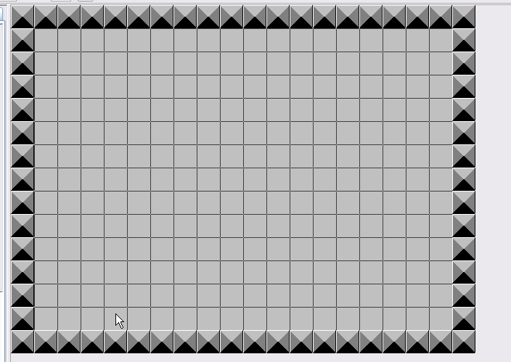 | Left-click to add  (right click to delete)
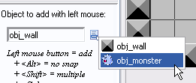 | Now select a monster and click to place him somewhere in the middle….
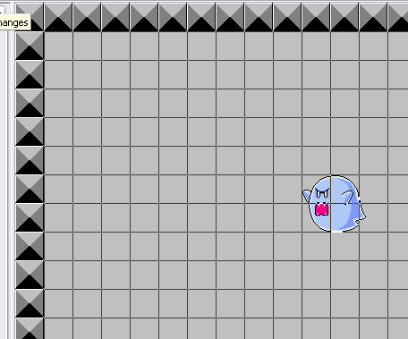 | Click to save changes…  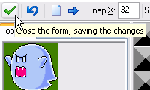
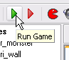 | Test your game!
 | Cool – but a little plain. Let’s add a background.
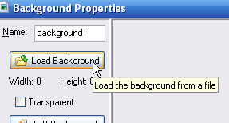 | Click Add a Background and shop around. 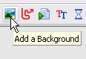
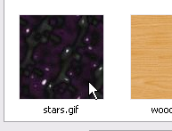 | I’m adding stars.  Name and save.
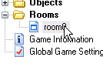 | Go back to Rooms and click on Background 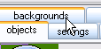
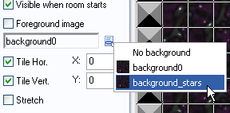 | Choose the stars background – test the game.
 | But wouldn’t it be great if the starfield were moving?
 | Go back to the room
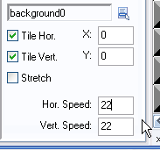 | Change the Horizontal and/or Vertical speed. Test until you get it the way you like it.
 | Yes! But how about making the game harder? Let’s add a different monster that loses points when clicked on.
Click the Add Sprite icon | Let’s add a new picture, or “sprite” to be the Not monster.
Click the Load Sprite button. Look in the different folders – choose a good one.
I’m going to use a slightly different Mario monster
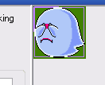 | It’s a good idea to name your sprites so you can find them later. Never use a space in the name!
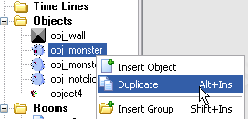 | This is a little tricky – Go to the Objects folder, Right-click the obj_monster icon and choose Duplicate.
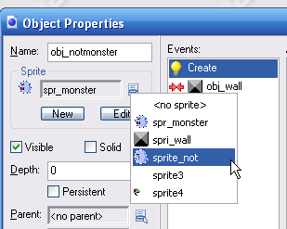 | Open it up and name it obj_notmonster.  Choose the new notmonster sprite.
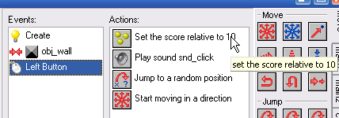 | Now, we’re going to tell the game to take points away when they click on the Not-Monster.  Click the left-button icon,  Then click the Set Score icon.
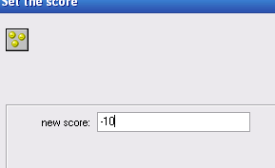 | Double-click to open  Set score to -10  And save.
We need to add Not-Monster to the game!

Go back to the room
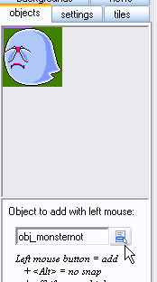 | Click on Objects tab  Select your Not-Monster from the drop-down box, and left-click somewhere in the room to put him in there.  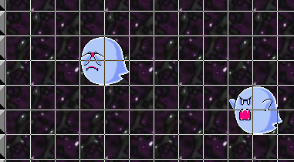
 | Now test it!
You can put it as many of either monster as you like.

You can build wall areas for the monsters to smash around in.

You might want to add a different sound to the Not-Monster..
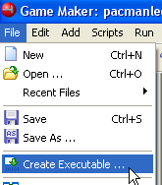 | Now let’s make an “executable” copy of your game that you can take with you and let your friends play – choose Create Executable, save it. We’ll help you move your game onto a free CD that you can take home with you.
 | It’ll look like this, more or less – just click on it to play!

