We’re going to create a Flying Bat in Fireworks  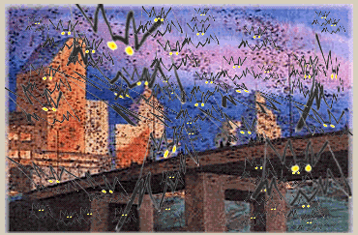  You’ll be able to email your flying bat to your friends! | We’re going to celebrate the march return of the bat colony to austin’s town lake bridge.  Create a Great bat, then copy your bat as a flock and teach the flock to fly past the town lake bridge!
Start up Fireworks | Click the New File button at the top left.  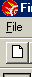
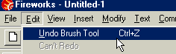  CTRL-Z | Your Magic Assistant –  Edit – Undo  Don’t be afraid to experiment – you can always Edit-undo your last step.  Lots of software will let you do this!
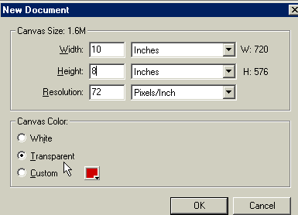  Be sure and choose Inches, not Pixels | We’re going to make our background  10 inches wide and  8 inches high  And transparent.  Click “ok”
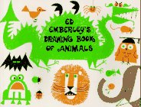  Which is probably right here in your own library! | We’re drawing our bat pretty much the way Ed Emberley teaches in  Ed Emberleys Drawing Book of animals.
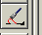 | First, choose the Paintbrush from the tools at the left side of the page.
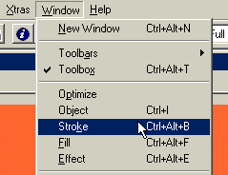 | We’re going to use some cool strokes, so let’s open the Stroke command window.
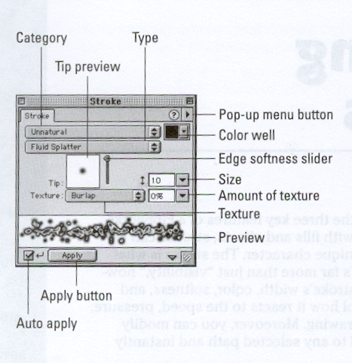 | The stroke menu in fireworks is like a whole artist’s studio – you can draw with crayon, felt tip, charcoal, an air brush, a calligraphy pen, all any size and color you need as an artist
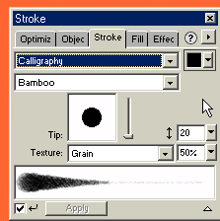 | To start drawing our bat, we’re going to use the Calligraphy stroke.  About 20 pt for the size of the stroke.
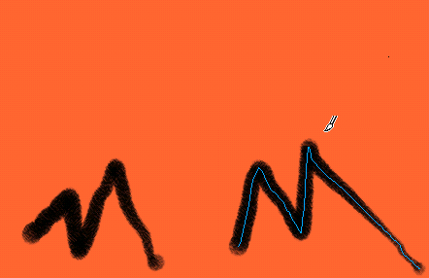 | First, we’ll draw two M-looking things down towards the bottom.
Save Your Work Often!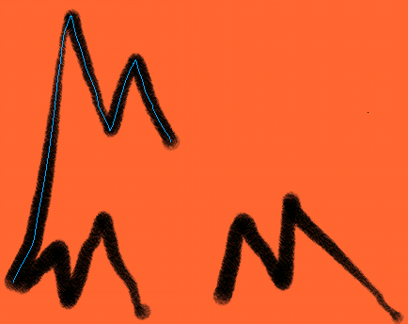 | Then, we’ll draw two more M things, but with long sides to connect up to the bat’s top wings.
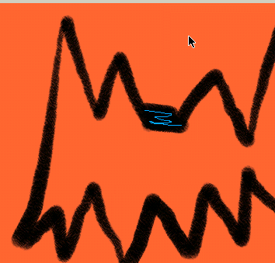 | Next, we’ll connect up the bat’s head at the top  and at the bottom, connect that up with a sort of upside-down V.
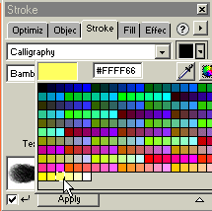  Now, on the stroke menu, let’s click the color box and switch to whatever color you want the eyes to be – I’m choosing yellow. | It’s time to make the eyes.  When you want to change the color or stroke, Deselect by Holding down the control button and clicking D  so the changes we’re about to make don’t mess up your bat.
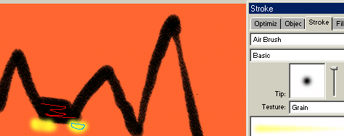 | You can also switch from Calligraphy to Air Brush, if you like – it gives it a glow-wy effect.
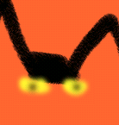 | Then, if you like, switch the color box back to black or orange and put in pupils in the bat’s eyes.  CTRL-D when switching colors
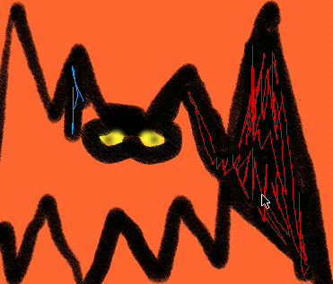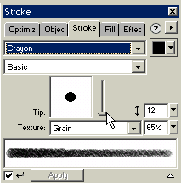 | Now, color in your bat, if you like.  I’ve found that Crayon is the easiest stroke to use for this.  You may want to draw around your bat’s eyes so they don’t get messed up.
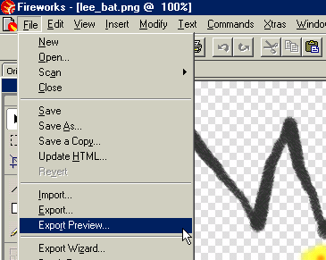 | Now, let’s export your bat in the WFY folder.  Go to file—export preview
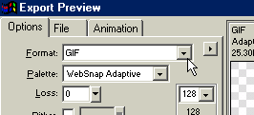 | At the top, under  Format – choose gif  Then click export  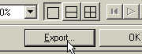  Name it yournamebat –  And make sure it’s in the wfy folder
Let’s open the Frames Command Window.  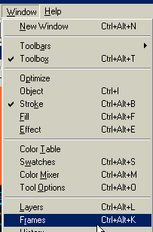 | Now we’re going to do the animation part – we’re going to make your bat  FLY!  We’re going to add another frame, copy your bat to the new frame, then go to the new frame and change the bat’s wings to the downward flap position.
LET’S OPEN THE BRIDGE PICTURE:  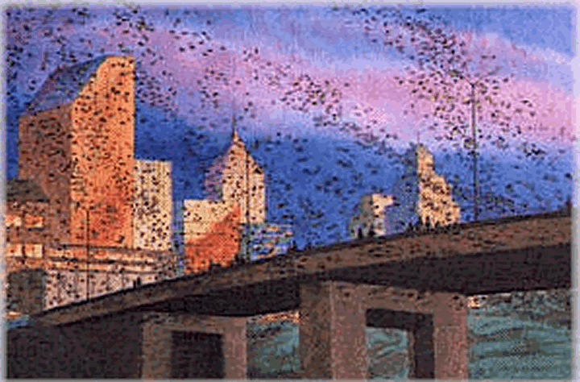 | Go to file—open  Go to WFY folder, then the batbridge folder.  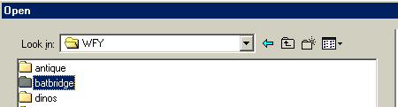  Then open the “batbridge_painting” file.
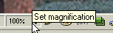 | Make sure your view of the picture is set at 100%
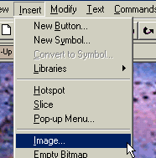 | Now, Let’s insert your bat – first one, then a flock  Go to Insert—Image  Navigate to your own bat picture – click
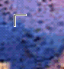 | You get a corner like this – click and drag to insert your bat in the size you want – you can always change the size later, so don’t worry
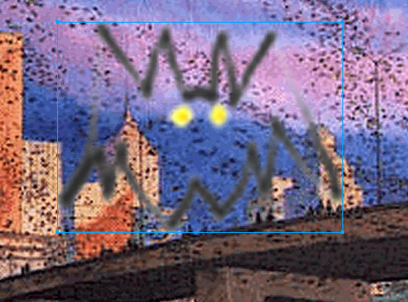 | Probably want to make him smaller than this, tho
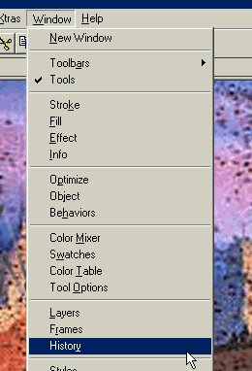 | Now to easily insert your bat a bunch of times, let’s learn a shortcut  Go to window---history
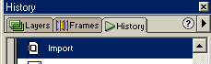 | Choose the line that says “Import” and looks like this:
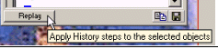 | Then click the  “Replay” button
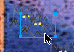 | Click on your bat and click and drag your new bat away from the first one
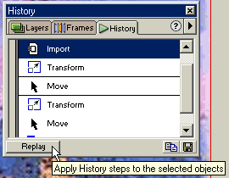 | Then click the  “Replay” button about 12 or 15 times – moving the new one away each time  each time you’ll be quickly inserting a new bat!
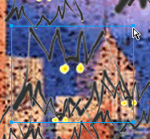 | Now change up your flock!  You probably know how to make your bat bigger by clicking on the “handles” on the sides and dragging…
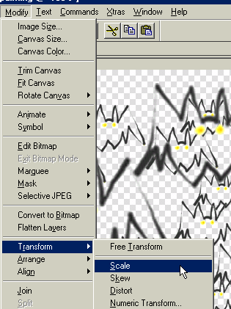 | But you can also transform your bat by choosing  Modify—  transform—  - scale  - skew  - distort  skew:  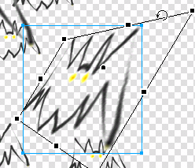  distort:  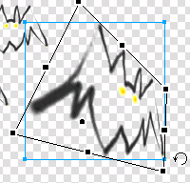
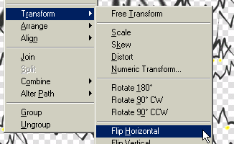 | You can change your bat so that he’s facing the other direction –  Transform – flip horizontal
Let’s open the Frames Command Window. | Now we’re going to do the animation part – we’re going to make your bat  FLY!  We’re going to add more frames and change up your bats in each frame – it’ll look like they’re flying…………
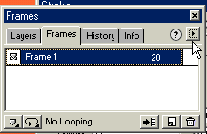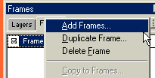 | In the Frames Command Window, click on the little box there at the top right – it’ll expand out a menu.  Choose Duplicate Frame
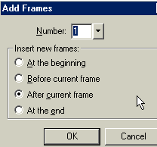 | We’ll Duplicate the first frame and put the copy after the current frame.
Great job. 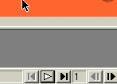 Now look at the bottom right of your screen – see those controls that look like VCR buttons? Those will “play” your bat movie. | Click now, and you’ll see that the screen goes from one bat frame to another, though both pictures are still the same.  But we’re going to change that right now.
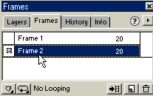 | Click on Frame 2  It’s the copy of your bat that we’re going to change.
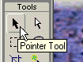 | Make sure you’re using the pointer tool….
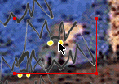 | Hover over the bat you want to change – the box will turn red – when you click on it to select it, it will turn blue.  Now change this bat – click and drag and move it – transform it with transform tools -- change a bunch of your bats!
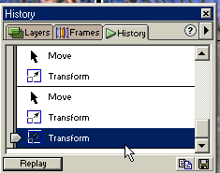  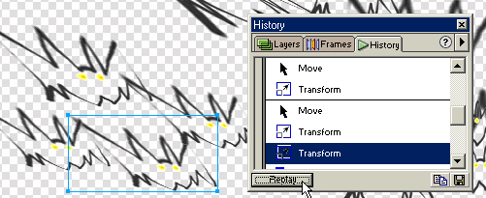 | If you get a transform effect you like, use the history tool again –  choose a bat, choose the transform effect, and click “replay”
Now, go back to the VCR controls at the bottom of the page and click the play button.

Your bat flock now flies!!
Now let’s export your bat picture in “.gif” format so we can put it on the web.

Go to File—Export preview again;
--Choose Animated Gif
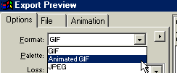

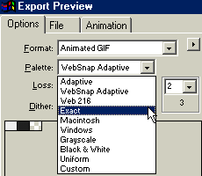 | You’ll probably have to change the Palette part to “Exact” if you want your colors exactly as you’ve drawn them.
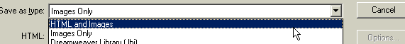 | If you’d like to take your animation home with you on a disk, under  “save as type”,  choose:  “HTml and images”
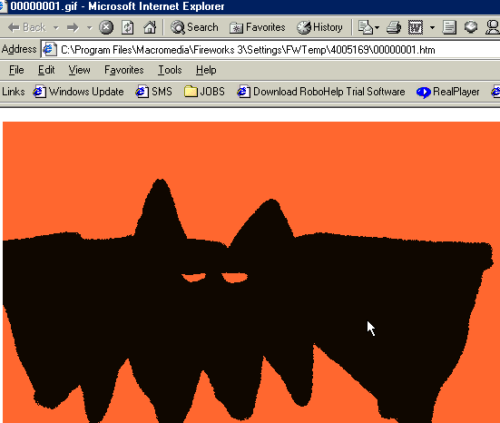 | Now you’re an animation expert!  What else can you animate?
Make an Animated greeting card and send it as an email attachment to your friends!
Check out one of the ed emberley books for ideas on other things to animate –

ask a librarian about more art books for kids!

