 | We’re going to compose music, just like many of the stars of Austin City Limits/Austin Kiddie Limits!  We’ll use the award-winning Music MasterWorks software.
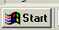   | To open the program, click on the start button in the far left hand corner.  Pull up to programs and then across to Music Masterworks
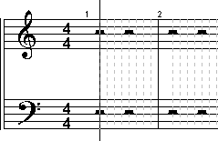 | This is what you see when you open the program.
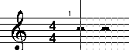 | The top half, with this S looking symbol, is called the Treble Clef -– it’s where higher notes go.
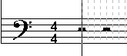 | The bottom half, with the backwards C looking thing, is called the Bass Clef – it’s where the lower notes go.
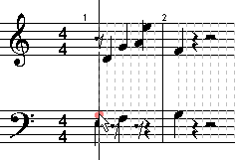 | With your mouse, you can point and click notes right on the musical staff anywhere you want – try clicking a few.  You’ll hear the notes sound as you click ‘em.
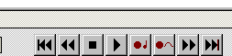 | Now look down at the bottom of the screen – see the VCR controls? Click rewind and play and hear what you’ve created!
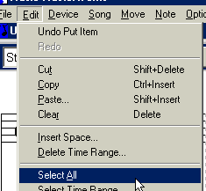 | Now, click edit—select all,  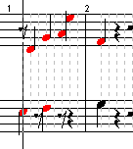All the notes turn red, to show you’ve selected them
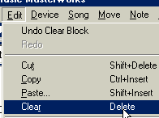 | Now, click Edit—clear, or the delete key on your keyboard.
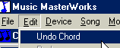 | Remember our old friend, Edit—Undo?  It’s in this program too!  Always look for it in new software – it’ll make you life a lot easier!
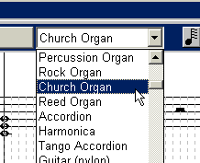 | Choose Church organ from the drop down list of instruments –  It’s the best start to our scary soundtrack….
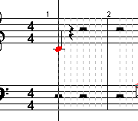 | Now, we’ll learn how to make the notes last longer.  Create a note, anywhere
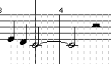  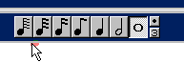  You can also experiment with different lengths of notes by clicking a note and clicking once on one of the notes at the top right of the screen with the note duration selector | Now look at your keyboard and find the  +  Key . It’s next to the backspace key.  With the note selected, hit the + key once, twice, three, four times and see that each time, the note selected gets longer!
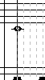 | Create a whole note  With the note still highlighted, find the letter “c” on your keyboard.  Click it once.
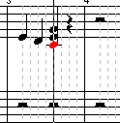  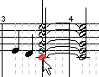 | The first time you click it, it puts other notes on the staff for you – this forms what’s called a Chord.  Hit the space bar to play those few notes and hear what the chord sounds like.  Try different chords by clicking the letter “c” again and again, and playing those.  Remember, you can click on any note to choose it and try out some chords – you’re the composer, so experiment until you find what you like.
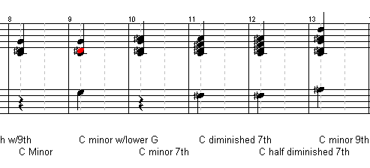  If you’re really curious, open up the “chords” file – play it and see which chords are minor chords | You’ll create a MINOR chord the 8th, 9th, 10th, and 13th times you click the “c” key.  But it’ll all sound spooky with the Church Organ instrument playing your creation.
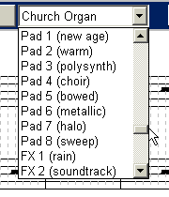 | Now try different scary sound effects – the “Pad” and the “FX” effects are all weird and kinda spooky.
 | Now we’ll add in some spooky sound effects that were already created for you – these are WAV files.
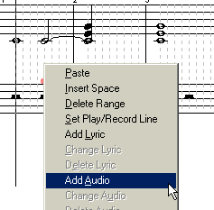 | Right-click on the music where you want your sound effect to start.  Choose Add Audio
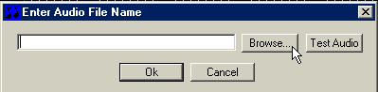 | You’ll get this menu – click Browse
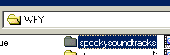  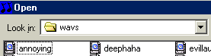 | Go to:  WFY – spookysoundtracks—wavs  Choose one
To hear what you’ve chosen, click “Test Audio”

If you like it, click OK; if you want to try another one, go back to Browse
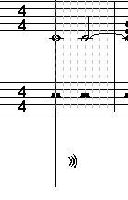 | When it’s inserted, a little wav-vy picture shows up.  Now, play your creation.  You can have as many extra wav file sound effects as you like….
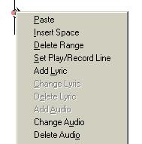 | If you right-click on the wav file symbol, you’ll get this menu, which lets you delete or change your sound effect.
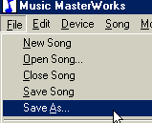 | If you get a song that you really like, you can “save as” and save your composition.  The song is saved as a MIDI file.  If you save it to the Wfy folder and then go back later and click on it, WinMedia will play it again for you.
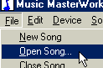 | Let’s look at a professional MIDI song – click Open Song
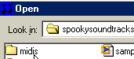 | Navigate to the Wfy folder, the spookysoundtracks folder, and this time, the midis folder
 | You’ll see that it’s possible to use this software to make a song sound like a whole symphony.
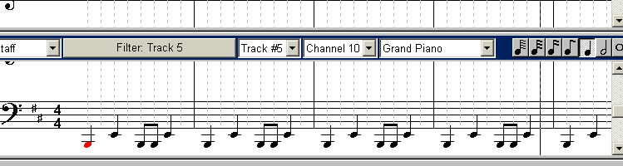 | Open up the Buffy Vampire Slayer soundtrack and scroll down to Track 5.  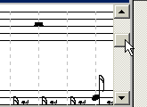  Click and drag on the bar at the far right to see the bass cleft, where most of the notes are. This is the cool drum beat part.
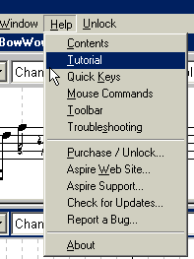 | We’ll be learning more about the really advanced features of the software later, but if you want to learn more on your own, go to the Help files in the software.
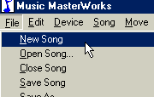 | Now we’re going to sing into the microphone and have the software write the notes we’ve sun onto the musical score.  Click New Song
Get your microphone ready – make sure it’s set to “On”.

As soon as you click the button, it’ll start recording.

Try a tune, or just sing whatever comes to mind. Sing very close to the microphone.
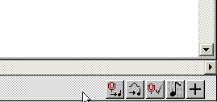 | Now, at the bottom right of the screen, click on the Voice-to-Notes icon:  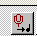
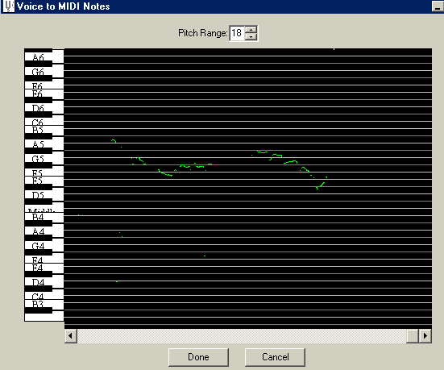 | As you sing into the microphone, you’ll see the notes being plotted on the graph.  If you don’t see any notes, try singing louder and closer to the microphone.  Click done when you’re done.
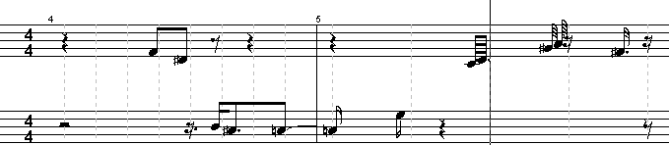 | You’ll see a new musical score of your composition.  You can play it back different ways, add chords, change up notes, whatever you like!
If you get a song that you really like, you can “save as” and save your composition.

The song is saved as a MIDI file.

.
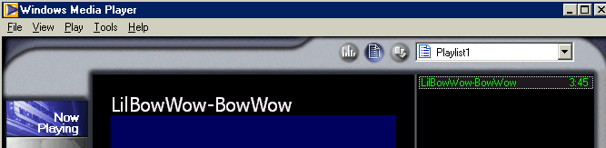 | If you save it to the Wfy folder and then go back later and click on it, WinMedia will play it again for you – so you can easily play your songs for your friends.
NOTE ABOUT MUSIC AND WEB PAGES!  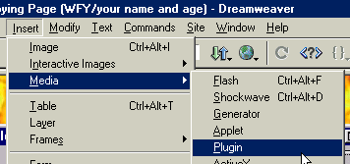 | If you have your own website in Dreamweaver, you can also put your song into your Dreamweaver web page.  When the music file is inserted, you’ll see this symbol:  
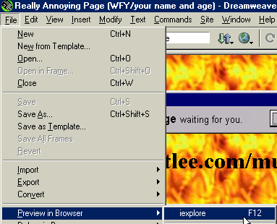 | To hear the music, you’ll have to save the file and then preview in browser.

