FX Halloween! 
We’re going to learn three ways to change up our digital pictures to make Special FX for a Halloween animation.   First, we’ll learn on existing pictures, then we’ll take your picture, and you can create whatever you want! |  | Free your imagination & create, just like you can do at the Exploration Station at the Austin Children’s Museum!
Important – be sure to choose the “open as anmation” option!!  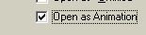 |  | Choose File – Open Multiple  Go to the WFY folder, then to the ACM_FX folder.  Select all the files there.
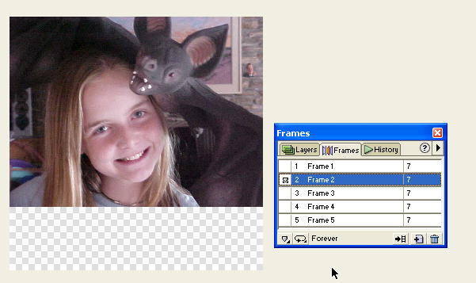 |  | It’ll look about like this:
The Frames window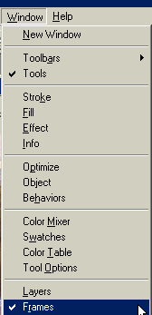 |  | If it’s not already open, open the frames window.  Go to:  Window---frames
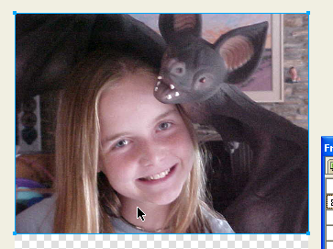 |  | Click on the picture to select it  When it’s selected, the box around it will be light blue.  (Before it’s selected, it’s a red box)
1 - we’ll do simple color changes on the picture of our model |  | 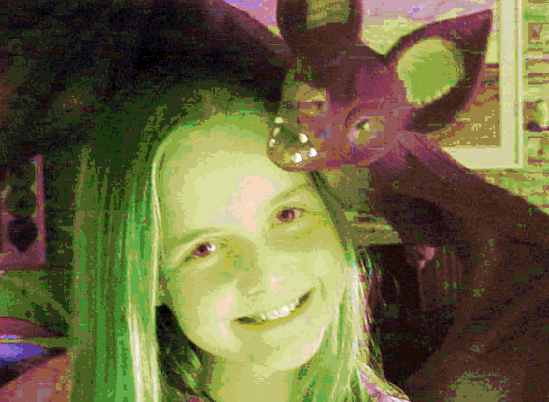
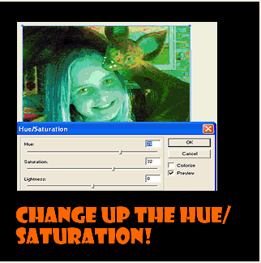 |  | 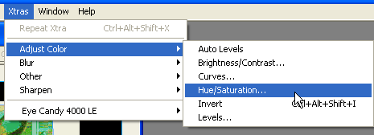  Go to Xtras – Adjust Color – Hue/Saturation  Hue – changes the color  Saturation – changes how much color
2 - we’ll cut and paste a part of the face and draw a costume around it! |  | 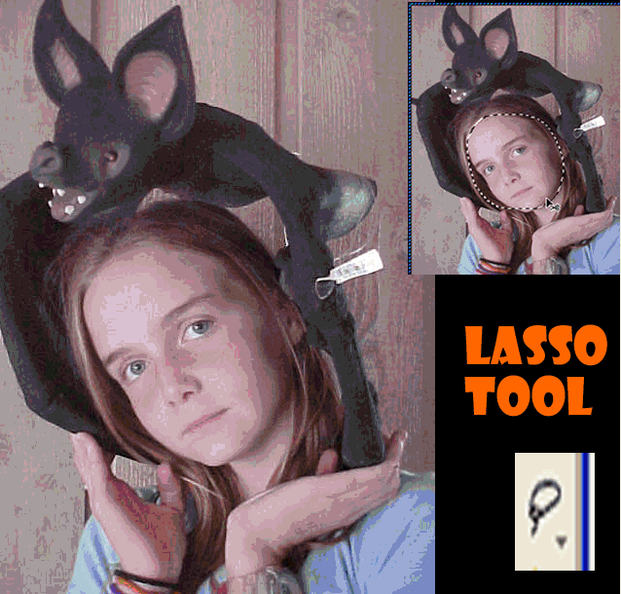  Use the Lasso Tool to select the face.
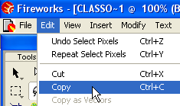 |  | Then, choose Edit – Copy  Or hold down the Control key and press the letter “c”
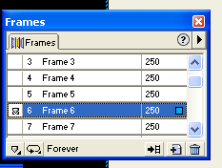 |  | Now we’ll create a blank frame to put the face in.  In the Frames box, see the little triangle guy at the top right?  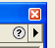  Click on that.
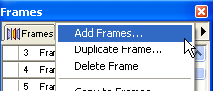 |  | Choose Add Frames
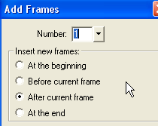 |  | Choose After Current Frame
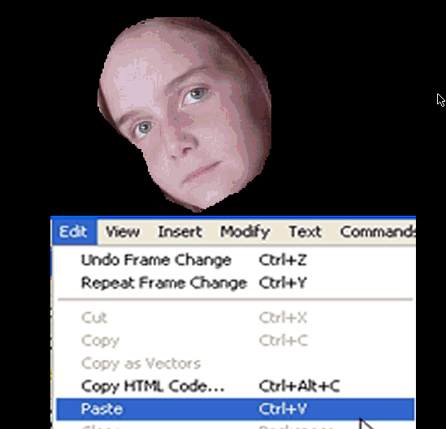 |  | Then click Edit – Paste, and this is what you get.
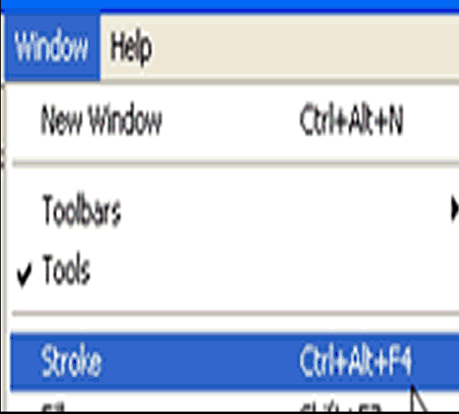 |  | Now we’ll draw a costume around the face  Open the Stroke Window
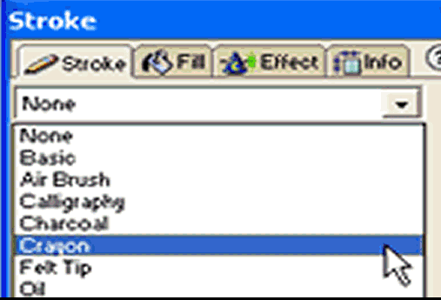 |  | Select a Stroke  Crayon or Air Brush are good for this project…
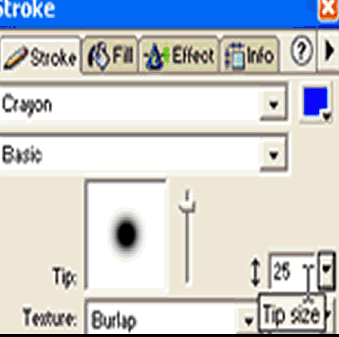 |  | Change the tip size and the color
 |  | Choose the Brush Tool from the tools at the left, and click and draw a costume – maybe a butterfly, maybe a bat, maybe a cat… 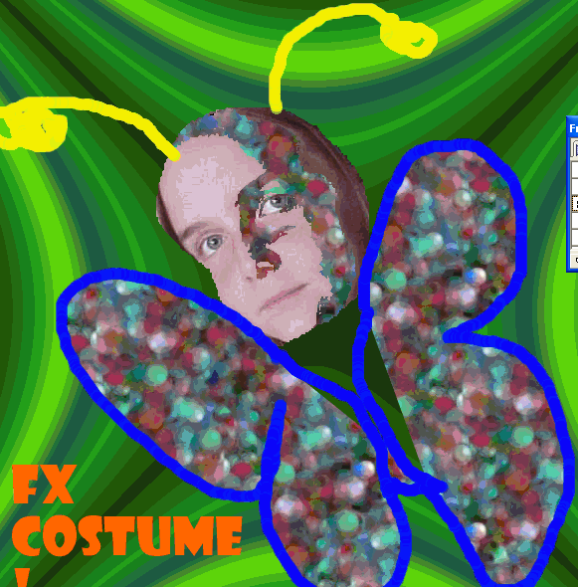
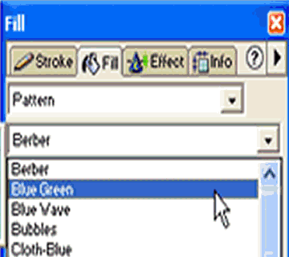 |  | To fill in the Butterfly wings, you can go to Fill (right there by the Stroke tab).  Choose Pattern, and browse through the drop down box.  Then click the Paint Bucket tool and fill in the wings!  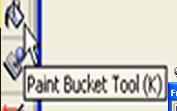
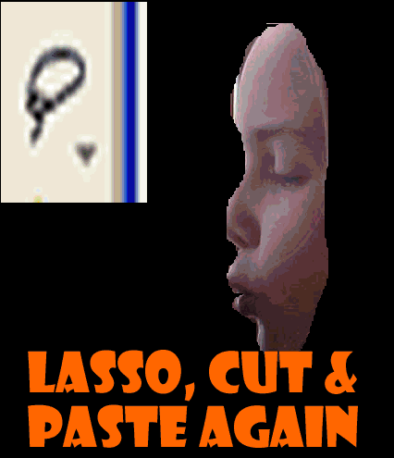 |  | 3 - Now, for the last, craziest FX method – the distortion!  Lasso, copy, make a new frame and paste like we did last time…
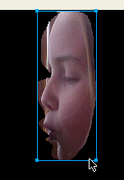 |  | Make sure the face itself is selected in a blue box – use the Pointer Tool if you need to:  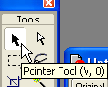
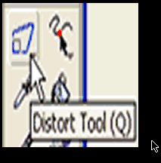 |  | Now find the Distort Tool at the left.  You may have to click and hold on the Scale Tool to find the Distort tool underneath – it’s the last one  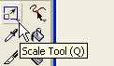  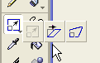
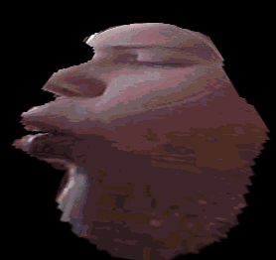 |  | Now click and drag on the “handles” on the corners to get some weird FX!  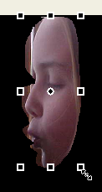
Now, on YOUR pictures, we’ll mix up what effects you use –  You can change the hue & saturation, then cut out your face, then distort it, for example… |  | Remember, this is an animation, so you can change your picture slightly in each frame to get very cool FX!
Now, with your pictures!  Important – be sure to choose the “open as anmation” option!! |  | Choose File – Open Multiple  Go to the A: floppy drive  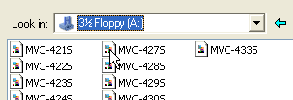  Select all the files there.
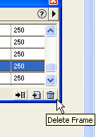 |  | Select all the files, and later, any frames you decide you don’t want, you can just delete by selecting the frame and clicking the little trash can at the bottom right.
You’re an expert now – create!  …………………but don’t forget…  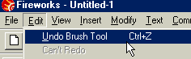 |  | Your Magic Assistant –  Edit – Undo  Don’t be afraid to experiment – you can always Edit-undo your last step.
 | How to save your movie!
 | 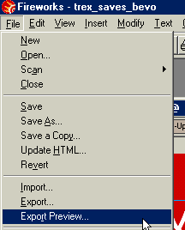 |  | Go to “File—  Export Preview”
 | 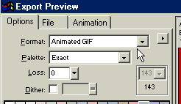 |  | Make sure the format is  “animated gif”
 | 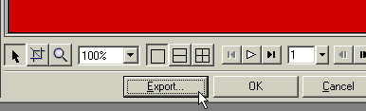 |  | Click “export”
 | 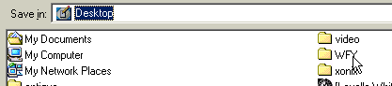 |  | Be sure you save to the wfy folder!!!
 |  |  | Give your movie a name and click “save”
 | 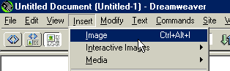 You can insert your movie into your web page in Dreamweaver – just click Insert—Image! |  | It’s saved as an Animated gif and will have the .gif at the end.

